**Activity 2**

**Finance Management App**

**Requirements Analysis**

**F.R. 1: Create Account:** Users should be able to register by entering a valid email address or phone number and setting a password. An email/phone verification mechanism should be in place.

**F.R. 2: Login:** Registered users can log in using their email or phone number and password.

**F.R.3: Third-Party Login:** Integrate third-party authentication options (e.g., Google, Facebook) for a faster sign-in process.

**F.R. 4: Forgot Password:** Users can reset their password via an email or phone verification process.

**F.R. 5: Update Profile:** Users can update their name, contact information, and profile picture.

**F.R. 6: Account Security:** Include two-factor authentication (2FA) for secure login.

**F.R. 7: Add Income Sources:** Input various income sources (e.g., salary, freelance, rental income) with details such as amount, frequency, and source type.

**F.R. 8: Edit Records:** Users can modify income entries if needed.

**F.R. 9: Delete Records:** Users can delete income entries if needed.

**F.R. 10: Categorization:** Predefined categories such as rent, utilities, groceries, and entertainment. Users can add custom categories.

**F.R. 11: Expense Entry:** Log expenses with details like amount, date, and category.

**F.R. 12: Delete Expense:** Users can delete expense.

**F.R. 13: Edit Expense:** Users can edit expense.

**F.R. 14: Goal Creation:** Users can set specific financial goals (e.g., saving for a vacation, debt repayment) by entering the target amount and deadline.

**F.R. 15: Delete goal:** Users can delete goals.

**F.R. 16: Edit goal:** Users can edit goals.

**F.R. 17: Create budget:** System create budget for the user.

**F.R. 18: View articles:** User view articles and watch videos for effective tips.

**F.R. 19: Bookmark sources:** User can bookmark articles/videos.

**F.R. 20: Access bookmarks:** Users can access bookmarks.

**F.R. 21: Goal Reminders:** Send periodic updates on goal progress.

**F.R. 22: Detailed Reports:** Generate detailed reports for selected timeframes, showing income, expense trends, and budget performance.

**F.R. 23: Export Reports:** User exports reports for external use (e.g., PDF).

**F.R. 24: Upload Articles/videos:** User can upload articles and watch videos for effective tips on finance management.

**N.F.R 1:** The system must handle up to 10,000 concurrent users with a response time of <2 seconds for core operations like login, adding income, or viewing reports.

**N.F.R 2:** The system should scale seamlessly to accommodate an increase in users, transactions, and data volume.

**N.F.R 3:** User data must be encrypted using AES-256 for data at rest and HTTPS/TLS for data in transit.

**N.F.R 4:** All data changes (e.g., adding income, expenses) should reflect across all devices in real time with consistent backups to ensure no data loss during failures.

**N.F.R 5:** The UI should be intuitive and responsive on desktop and mobile devices. Users should be able to perform core tasks (e.g., adding income/expenses or updating profiles) within 3 clicks or fewer.

**Actors**

* **Families:** To manage shared household budgets.
* **Individuals:** To track personal financial health and savings.
* **Small Businesses:** To monitor operational income and expenses.
* **System Administrator:** Manages app operations, data security, and user issues.
* **Financial Advisors:** Provide expert content such as articles and tutorials.
* **Investors:** Back the development and feature expansion of the app.

**Use Case List**

**1. User Login and Registration**

* **Register a New Account:** User creates a new account using email or phone number.
* **Log In to Account:** User logs in using valid credentials.
* **Third-Party Authentication:** User logs in with Google or Facebook.
* **Password Recovery:** User resets their password via email or phone verification.

**2. User Account Management**

* **Update Profile Information:** User updates name, email, or contact information.
* **Set Preferences:** User customizes notification and display settings.
* **Enable Two-Factor Authentication:** User activates enhanced security for their account.

**3. Income Management**

* **Add` Income Source:** User logs income details such as source, amount, and frequency.
* **Edit Income Source:** User modifies an existing income record.
* **Delete Income Source:** User removes an income entry.
* **View Income Trends:** User visualizes income through charts or graphs.

**4. Expense Tracking**

* **Log an Expense:** User adds expense details with category and amount.
* **Edit Expense Entry:** User modifies an expense record.
* **Delete Expense Entry:** User removes an expense.
* **View Expense Trends:** User analyzes expenses by category and timeframe.
* **Create Custom Expense Category:** User adds personalized categories for expenses.

**5. Financial Goals**

* **Create a Financial Goal:** User sets a savings or financial target.
* **Track Goal Progress:** User monitors goal achievement.
* **Edit Financial Goal:** User updates target amount or deadline.
* **Delete Financial Goal:** User removes a goal.

**6. Educational Content**

* **Access Articles:** User views articles on financial management.
* **Watch Tutorials:** User watches interactive financial tutorials.
* **Search Educational Materials:** User searches and bookmarks resources.

**7. Reminders and Notifications**

* **Receive Expense Alerts:** System sends notifications for overdue expenses.
* **Receive Goal Reminders:** System reminds users about their financial goals.

**8. Visual Reports**

* **View Dashboard:** User sees a summary of key metrics.
* **Generate Reports:** User creates detailed financial reports.
* **Export Reports:** User exports reports for external use (e.g., PDF).

**9. Multi-Device Support**

* **Sync Data Across Devices:** User accesses synchronized financial data across devices.
* **Backup and Restore Data:** User restores app data from the cloud.

**10. Budget Creation**

* System analyze the income sources, goals and expense categories and create budget and notifies the user.

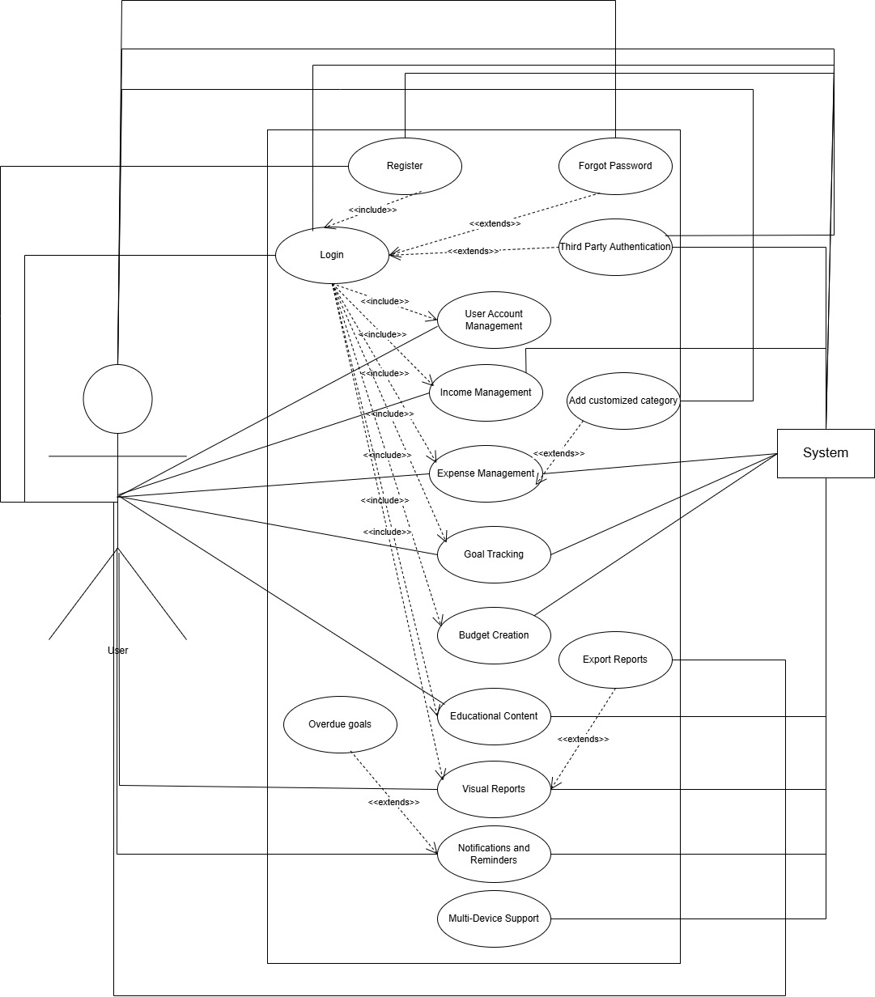

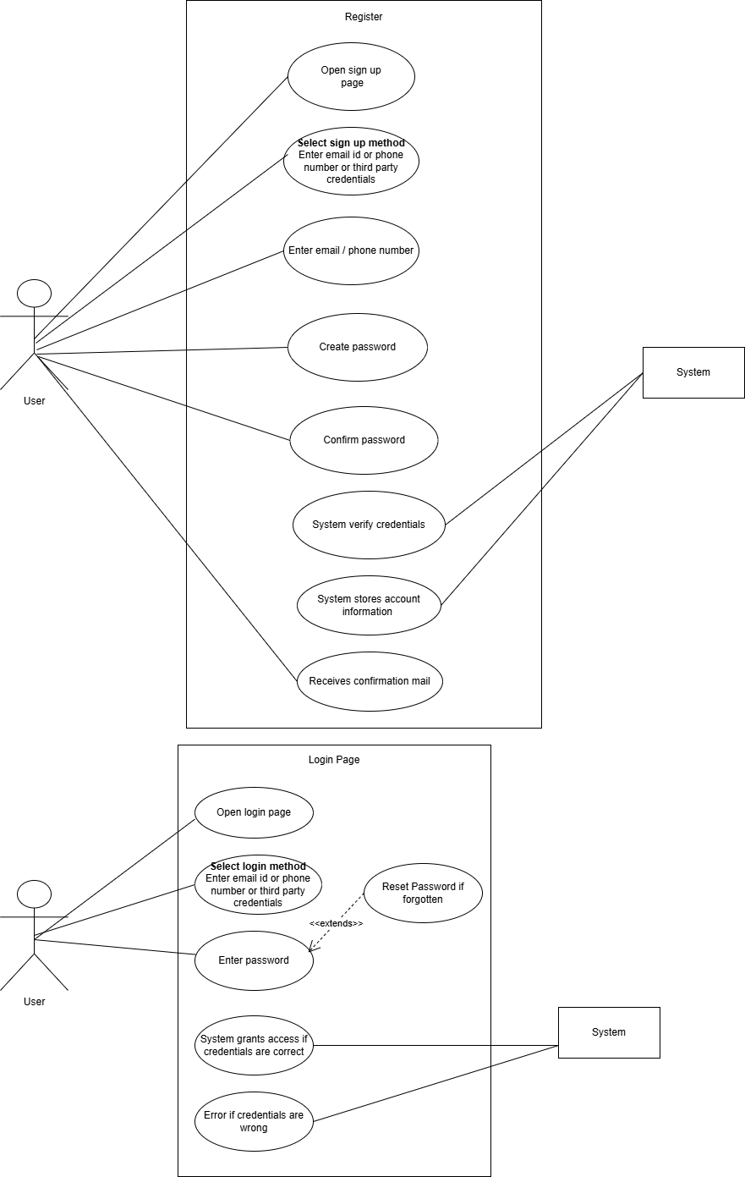

**Use Case 1: Login**

|  |  |
| --- | --- |
| **Section** | **Details** |
| **Use Case Name** | Login |
| **Created By** | Rabia |
| **Date Created** | 1st January 2025 |
| **Last Updated By** | Rabia |
| **Last Revision Date** | 1st January 2025 |
| **Actors** | User, System |
| **Description** | Allows a user to authenticate and gain access to the system. |
| **Trigger** | User enters login credentials and submits the login form. |
| **Preconditions** | User must be registered and have valid credentials. |
| **Postconditions** | User is authenticated and redirected to their dashboard. |
| **Normal Flow** | 1. User enters their username and password.  2. System validates the credentials.  3. If valid, user is logged in and redirected. |
| **Alternative Flows** | 1A. User clicks on "Forgot Password" to recover credentials.  2A. System sends a password recovery email. |
| **Exceptions** | 1. Invalid credentials.  2. Network issues prevent login. |
| **Includes** | "Forgot Password" use case. |
| **Frequency of Use** | Multiple times per day. |
| **Special Requirements** | Secure connection (HTTPS), CAPTCHA to prevent bots. |
| **Assumptions** | System is operational, and the database is accessible. |
| **Notes and Issues** | May require multi-factor authentication for sensitive systems. |
| **Use Case ID** | UC-1 |

|  |  |
| --- | --- |
| **Section** | **Details** |
| **Use Case Name** | Register |
| **Created By** | Rabia |
| **Date Created** | 1st January 2025 |
| **Last Updated By** | Rabia |
| **Last Revision Date** | 1st January 2025 |
| **Actors** | User, System |
| **Description** | Allows a new user to create an account in the system. |
| **Trigger** | User accesses the registration page and submits the form. |
| **Preconditions** | User must provide all mandatory information (e.g., email, password). |
| **Postconditions** | A new user account is created, and the user is logged in or redirected to the login page. |
| **Normal Flow** | 1. User fills in the registration form with valid details.  2. System validates the input.  3. If valid, system creates the user account.  4. User is notified of successful registration. |
| **Alternative Flows** | 1A. User enters an already registered email address.  2A. System displays an error message and suggests logging in instead. |
| **Exceptions** | 1. Network issues prevent registration.  2. System encounters a server error during account creation. |
| **Includes** | Email verification process. |
| **Frequency of Use** | Once per user, initially. |
| **Special Requirements** | Validation of email address format, strong password enforcement. |
| **Assumptions** | User has internet access and a valid email address. |
| **Notes and Issues** | Ensure data protection regulations are met (e.g., GDPR). |
| **Use Case ID** | UC-2 |

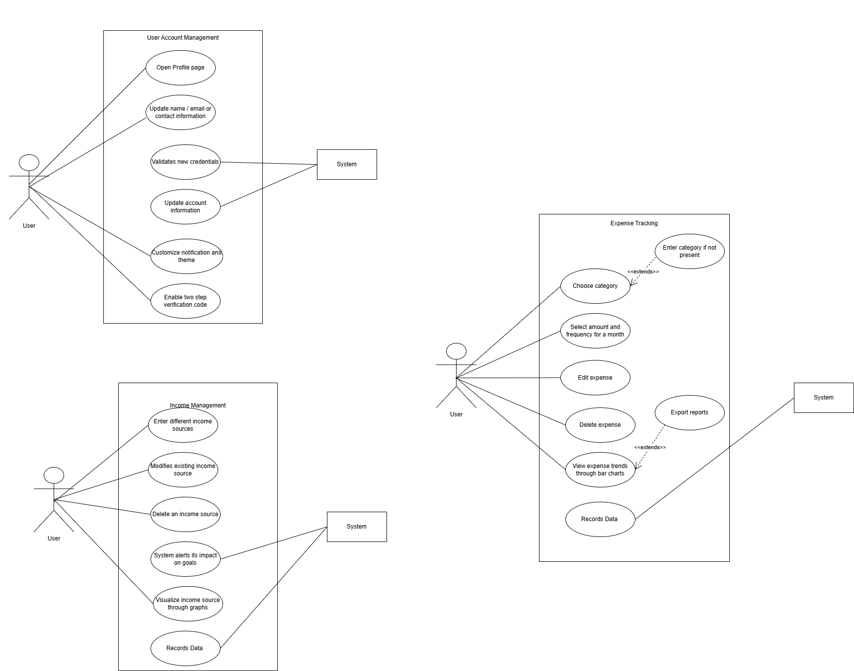

|  |  |  |  |  |  |  |  |  |  |  |  |  |  |  |  |  |  |  |  |  |  |  |  |  |  |  |  |  |  |  |  |  |  |  |  |  |  |  |  |  |  |  |  |  |  |  |  |  |  |  |  |  |  |  |  |  |
| --- | --- | --- | --- | --- | --- | --- | --- | --- | --- | --- | --- | --- | --- | --- | --- | --- | --- | --- | --- | --- | --- | --- | --- | --- | --- | --- | --- | --- | --- | --- | --- | --- | --- | --- | --- | --- | --- | --- | --- | --- | --- | --- | --- | --- | --- | --- | --- | --- | --- | --- | --- | --- | --- | --- | --- | --- |
| |  |  | | --- | --- | | **Section** | **Details** | | **Use Case Name** | User Account Management | | **Created By** | Rabia | | **Date Created** | 1st January 2025 | | **Last Updated By** | Rabia | | **Last Revision Date** | 1st January 2025 | | **Actors** | User | | **Description** | Allows users to manage their account by updating profile details, setting preferences, and enabling two-factor authentication. | | **Trigger** | User selects the "Account Settings" option from the menu. | | **Preconditions** | User is logged in and has access to the account settings feature. | | **Postconditions** | Profile information and preferences are updated, credentials are validated, and security is enhanced if two-factor authentication is enabled. | | **Normal Flow** | 1. User accesses account settings. | |  | 2. User updates profile information (name, email, contact). | |  | 3. System validates the new credentials. | |  | 4. User customizes notification and display preferences. | |  | 5. User enables two-factor authentication. | |  | 6. System saves changes and updates the account. | | **Alternative Flows** | - User skips enabling two-factor authentication and updates only profile or preferences. | |  | - User reverts changes before saving. | | **Exceptions** | - Invalid email or contact number entered. | |  | - Failure to enable two-factor authentication due to network issues. | |  | - System rejects invalid credentials during validation. | | **Includes** | Email validation, Preference saving, Two-factor authentication setup. | | **Frequency of Use** | As needed | | **Special Requirements** | Intuitive UI for updating profile and preferences. | | **Assumptions** | User provides valid details and has access to email or phone for two-factor authentication. | | **Notes and Issues** | Ensure email and contact validation; notify the user if any issue arises during two-factor authentication setup. | | **Use Case ID** | UC-3 | |

|  |  |  |  |  |  |  |  |  |  |  |  |  |  |  |  |  |  |  |  |  |  |  |  |  |  |  |  |  |  |  |  |  |  |  |  |  |  |  |  |  |  |  |  |  |  |  |  |  |  |  |  |  |  |  |  |  |  |  |  |  |  |  |  |  |
| --- | --- | --- | --- | --- | --- | --- | --- | --- | --- | --- | --- | --- | --- | --- | --- | --- | --- | --- | --- | --- | --- | --- | --- | --- | --- | --- | --- | --- | --- | --- | --- | --- | --- | --- | --- | --- | --- | --- | --- | --- | --- | --- | --- | --- | --- | --- | --- | --- | --- | --- | --- | --- | --- | --- | --- | --- | --- | --- | --- | --- | --- | --- | --- | --- |
| |  |  | | --- | --- | | **Section** | **Details** | | **Use Case Name** | Income Management | | **Created By** | Rabia | | **Date Created** | 1st January 2025 | | **Last Updated By** | Rabia | | **Last Revision Date** | 1st January 2025 | | **Actors** | User, System | | **Description** | Enables users to manage their income details by adding, editing, deleting income sources, and viewing income trends. The system updates the impact of income changes on financial goals. | | **Trigger** | User selects the "Income Management" option from the menu. | | **Preconditions** | User is logged in and has access to the income management feature. | | **Postconditions** | Income records are updated, and the system reflects changes in financial goals based on modified income data. | | **Normal Flow** | 1. User navigates to the income management section. | |  | 2. User adds a new income source, entering source name, amount, and frequency. | |  | 3. System saves the income source and updates financial goals accordingly. | |  | 4. User modifies an existing income source. | |  | 5. System validates the changes and updates financial goals. | |  | 6. User deletes an income source. | |  | 7. System removes the income source and recalculates the impact on financial goals. | |  | 8. User views income trends in charts or graphs. | | **Alternative Flows** | - User adds income details but cancels before saving. | |  | - User edits an income source but reverts changes before saving. | |  | - User attempts to delete an income source but cancels the operation. | | **Exceptions** | - Invalid income amount or frequency entered. | |  | - System fails to save income details due to technical issues. | |  | - System fails to generate income trends due to insufficient data. | | **Includes** | Data validation, Visualization of income trends, Goal recalculations. | | **Frequency of Use** | Regularly as income details change or for tracking purposes. | | **Special Requirements** | - Intuitive UI for income management. | |  | - Charts/graphs should be visually appealing and easy to understand. | | **Assumptions** | User provides valid and accurate income details. | | **Notes and Issues** | Ensure system efficiently recalculates financial goals after any income update. | | **Use Case ID** | UC-4 | |

|  |  |
| --- | --- |
|  |  |
| **Use Case Name** | Expense Tracking |
| **Created By** | Rabia |
| **Date Created** | 1st January 2025 |
| **Last Updated By** | Rabia |
| **Last Revision Date** | 1st January 2025 |
| **Actors** | User, System |
| **Description** | Allows users to log, edit, and delete expenses, create custom categories, and view expense trends by category or timeframe. The system records the data for analysis. |
| **Trigger** | User selects the "Expense Tracking" option from the menu. |
| **Preconditions** | User is logged in and has access to the expense tracking feature. |
| **Postconditions** | Expense details are updated, and the system records the data for further analysis or goal adjustments. |
| **Normal Flow** | 1. User navigates to the expense tracking section. |
|  | 2. User logs an expense, entering details like category, amount, and date. |
|  | 3. System saves the expense data. |
|  | 4. User edits an existing expense entry. |
|  | 5. System validates the changes and updates the record. |
|  | 6. User deletes an expense entry. |
|  | 7. System removes the expense record from the database. |
|  | 8. User views expense trends in charts or tables by category or timeframe. |
|  | 9. User creates custom expense categories for personalization. |
|  | 10. System saves the new category for future use. |
| **Alternative Flows** | - User logs an expense but cancels before saving. |
|  | - User edits an expense entry but reverts changes before saving. |
|  | - User attempts to delete an expense but cancels the operation. |
| **Exceptions** | - Invalid category or amount entered. |
|  | - System fails to save, update, or delete expense data due to technical issues. |
|  | - Insufficient data for generating expense trends. |
| **Includes** | Data validation, Visualization of expense trends, Goal recalculations. |
| **Frequency of Use** | Regularly for tracking expenses and managing finances. |
| **Special Requirements** | - Intuitive UI for expense tracking. |
|  | - Charts/graphs should be visually appealing and easy to interpret. |
| **Assumptions** | User provides accurate and valid expense details. |
| **Notes and Issues** | Ensure system efficiently handles data storage and retrieval for trends analysis. |
| **Use Case ID** | UC-5 |

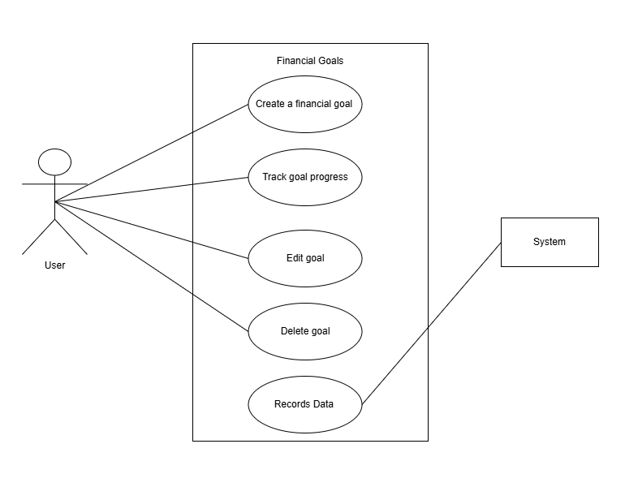

|  |  |
| --- | --- |
|  |  |
| **Use Case Name** | Set Financial Goals |
| **Created By** | Rabia |
| **Date Created** | 1st January 2025 |
| **Last Updated By** | Rabia |
| **Last Revision Date** | 1st January 2025 |
| **Actors** | User |
| **Description** | Allows users to set, track, and adjust financial goals. |
| **Trigger** | User selects the "Set Financial Goal" option. |
| **Preconditions** | User is logged in and has defined income and expenses. |
| **Postconditions** | Financial goals are set and tracked against the user's progress. |
| **Normal Flow** | 1. User enters goal details (target amount, timeline). |
|  | 2. System saves the goal and monitors progress. |
|  | 3. User receives updates on goal status. |
| **Alternative Flows** | - Notify user if goal progress is lagging behind. |
| **Exceptions** | - Unrealistic or unachievable goals entered. |
| **Includes** | Goal adjustment recommendation. |
| **Frequency of Use** | Monthly or as needed |
| **Special Requirements** | Provide recommendations for goal adjustments based on progress. |
| **Assumptions** | Users have a clear understanding of their financial capabilities. |
| **Notes and Issues** | Notify users when a goal is achieved. |
| **Use Case ID** | UC-6 |

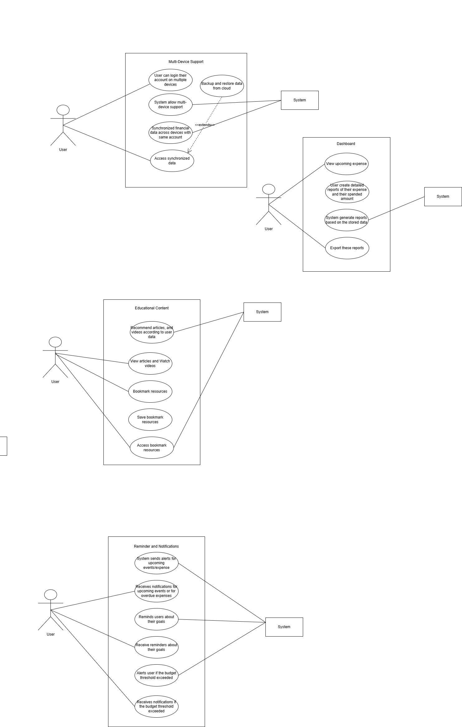

|  |  |
| --- | --- |
| **Section** | **Details** |
| **Use Case Name** | Multi-Device Support |
| **Created By** | Rabia |
| **Date Created** | 1st January 2025 |
| **Last Updated By** | Rabia |
| **Last Revision Date** | 1st January 2025 |
| **Actors** | User, System |
| **Description** | Enables users to access synchronized financial data across multiple devices and restore app data from the cloud. |
| **Trigger** | User logs into their account on a new device or initiates a backup/restore operation. |
| **Preconditions** | - User has a valid account. |
|  | - User is logged in on at least one device. |
|  | - Cloud storage is configured and operational. |
| **Postconditions** | - User’s data is synchronized across all logged-in devices. |
|  | - User’s data is backed up or restored successfully. |
| **Normal Flow** | 1. User logs into their account on a new device. |
|  | 2. System authenticates the user and retrieves financial data from the cloud. |
|  | 3. System synchronizes the latest data across all devices. |
|  | 4. User initiates a backup operation. |
|  | 5. System stores the latest data to the cloud. |
|  | 6. User initiates a restore operation. |
|  | 7. System retrieves the backup data from the cloud and restores it on the device. |
| **Alternative Flows** | - User cancels synchronization midway. |
|  | - User attempts to log in on a new device but fails authentication. |
| **Exceptions** | - Cloud storage service is unavailable or fails. |
|  | - Synchronization conflicts occur due to changes from multiple devices. |
|  | - Backup or restore operation fails due to insufficient storage or corrupted data. |
| **Includes** | - Login and authentication process. |
|  | - Data encryption for secure synchronization and backups. |
| **Frequency of Use** | - Regularly for keeping data consistent across devices. |
| **Special Requirements** | - Secure cloud storage. |
|  | - High-speed data transfer for real-time synchronization. |
| **Assumptions** | - User has an active internet connection. |
|  | - Cloud storage is set up and configured. |
| **Notes and Issues** | - Ensure secure data handling during synchronization and backup processes. |
| **Use Case ID** | UC-7 |

|  |  |
| --- | --- |
|  |  |
| **Use Case Name** | Reminders and Notifications |
| **Created By** | Rabia |
| **Date Created** | 1st January 2025 |
| **Last Updated By** | Rabia |
| **Last Revision Date** | 1st January 2025 |
| **Actors** | User, System |
| **Description** | The system notifies users of untracked expenses, budget thresholds, and goal progress through periodic alerts. |
| **Trigger** | - User sets reminders or budget thresholds. |
|  | - System detects spending patterns or evaluates goal progress. |
| **Preconditions** | - User has enabled notifications in settings. |
|  | - System has access to user’s expense and goal data. |
| **Postconditions** | - User receives notifications for untracked expenses, nearing budget limits, or updates on goal progress. |
| **Normal Flow** | 1. System analyzes user’s spending patterns and identifies untracked expenses. |
|  | 2. System sends an “Expense Alert” to notify the user of missing entries. |
|  | 3. User sets a budget threshold. |
|  | 4. System tracks spending and sends “Budget Alert” when the threshold is nearing or exceeded. |
|  | 5. User sets financial goals. |
|  | 6. System evaluates progress and sends periodic “Goal Reminders.” |
| **Alternative Flows** | - User disables specific notifications. |
|  | - User updates budget thresholds or goal settings after receiving alerts. |
| **Exceptions** | - Notifications fail to send due to server downtime or connectivity issues. |
|  | - System misidentifies untracked expenses due to incomplete data. |
| **Includes** | - Integration with notification system (push notifications, emails, etc.). |
| **Frequency of Use** | - Regularly, depending on user preferences for reminders and alerts. |
| **Special Requirements** | - Real-time analytics for spending patterns. |
|  | - Customizable notification preferences. |
| **Assumptions** | - User actively updates their expense and goal data. |
|  | - Notification delivery services are reliable. |
| **Notes and Issues** | - Ensure that notifications are concise and actionable to avoid user fatigue. |
| **Use Case ID** | UC-8 |

|  |  |
| --- | --- |
|  |  |
| **Use Case Name** | Dashboard and Visual Reports |
| **Created By** | Rabia |
| **Date Created** | 1st January 2025 |
| **Last Updated By** | Rabia |
| **Last Revision Date** | 1st January 2025 |
| **Actors** | User, System |
| **Description** | The system provides users with a summary of key financial metrics, generates detailed reports, and allows exporting reports for external use. |
| **Trigger** | - User accesses the dashboard or selects the option to generate/export a report. |
| **Preconditions** | - System has updated financial data for the user. |
|  | - User has logged into their account. |
| **Postconditions** | - User views a dashboard with summarized metrics. |
|  | - Reports are generated and optionally exported in the selected format. |
| **Normal Flow** | 1. User logs into the application and navigates to the dashboard. |
|  | 2. System retrieves and displays a summary of key metrics, such as income, expenses, and goal progress. |
|  | 3. User selects the "Generate Reports" option and specifies report parameters. |
|  | 4. System generates a detailed financial report based on the parameters. |
|  | 5. User selects the "Export Reports" option and chooses a format (e.g., PDF, Excel). |
|  | 6. System exports the report and notifies the user of successful completion. |
| **Alternative Flows** | - User refreshes the dashboard to update metrics. |
|  | - User cancels the report generation process. |
| **Exceptions** | - Dashboard fails to load due to incomplete or outdated financial data. |
|  | - Report generation or export fails due to insufficient data or system errors. |
| **Includes** | - Integration with reporting and exporting modules. |
| **Frequency of Use** | - Frequently, depending on user needs for insights and documentation. |
| **Special Requirements** | - Dashboard must display real-time or near-real-time metrics. |
|  | - Reports must support multiple export formats. |
| **Assumptions** | - User’s financial data is accurate and up-to-date. |
|  | - Exported reports are compatible with standard tools (e.g., Adobe Reader, Excel). |
| **Notes and Issues** | - Ensure dashboard is visually intuitive and easy to navigate. |
|  | - Optimize report generation for speed and accuracy. |
| **Use Case ID** | UC-9 |

|  |  |
| --- | --- |
|  |  |
| **Use Case Name** | Educational Content |
| **Created By** | Rabia |
| **Date Created** | 1st January 2025 |
| **Last Updated By** | Rabia |
| **Last Revision Date** | 1st January 2025 |
| **Actors** | User, System |
| **Description** | The system provides users with access to educational resources, including articles, tutorials, and a search functionality to explore and bookmark content. |
| **Trigger** | - User selects the "Educational Content" option or searches for resources. |
| **Preconditions** | - User is logged into their account. |
|  | - Educational content is available in the system. |
| **Postconditions** | - User views articles, tutorials, or bookmarked resources. |
|  | - User can bookmark and revisit desired materials. |
| **Normal Flow** | 1. User logs into the application and navigates to the educational section. |
|  | 2. System displays available articles and tutorials categorized by topic. |
|  | 3. User selects an article or tutorial to view. |
|  | 4. System loads the selected content for the user. |
|  | 5. User searches for specific resources using keywords. |
|  | 6. System displays search results matching the keywords. |
|  | 7. User bookmarks preferred resources for later access. |
| **Alternative Flows** | - User filters content by category or level (beginner, advanced). |
|  | - User navigates to bookmarked resources directly. |
| **Exceptions** | - No matching results are found for the search. |
|  | - Educational content fails to load due to system error or network issues. |
| **Includes** | - Integration with search and bookmarking modules. |
| **Frequency of Use** | - Frequently, depending on user interest in financial education. |
| **Special Requirements** | - Content should be engaging and easy to navigate. |
|  | - Tutorials must support video playback. |
|  | - Search functionality should be fast and accurate. |
| **Assumptions** | - System hosts a variety of high-quality financial educational materials. |
|  | - Users are interested in improving their financial literacy. |
| **Notes and Issues** | - Ensure content is updated regularly to remain relevant. |
|  | - Optimize video tutorials for different devices and network conditions. |
| **Use Case ID** | UC-10 |

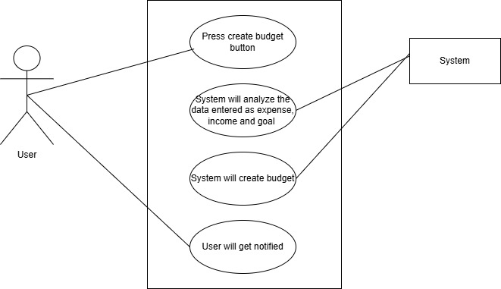

|  |  |
| --- | --- |
| **Section** | **Details** |
| **Use Case Name** | Create Budget |
| **Created By** | Rabia |
| **Date Created** | 1st January 2025 |
| **Last Updated By** | Rabia |
| **Last Revision Date** | 1st January 2025 |
| **Actors** | User |
| **Description** | Allows users to create a budget by analyzing their income, expense, and goals. If any input is missing, the system notifies the user. |
| **Trigger** | User selects the "Create Budget" button. |
| **Preconditions** | User is logged in and has defined income and expenses. |
| **Postconditions** | Budget is created, and the user is notified of success or any missing data. |
| **Normal Flow** | 1. User enters income, expenses, and goals. 2. User clicks "Create Budget" button. 3. System processes input data. 4. System creates budget and displays success message. |
| **Alternative Flows** | - Notify user if income or expense fields are missing. - Send email or message notification if data is incomplete. |
| **Exceptions** | - Missing income or expense input. - Invalid or incomplete data entries. |
| **Includes** | Sends notifications to the user if there is missing data. |
| **Frequency of Use** | As needed when users want to create or adjust their budget. |
| **Special Requirements** | - User should be notified by message or email if fields are missing. - System should notify user if budget is successfully created. |
| **Assumptions** | Users have accurate data for income and expenses. |
| **Notes and Issues** | Ensure that notifications are clear and actionable for missing data. |
| **Use Case ID** | UC-11 |

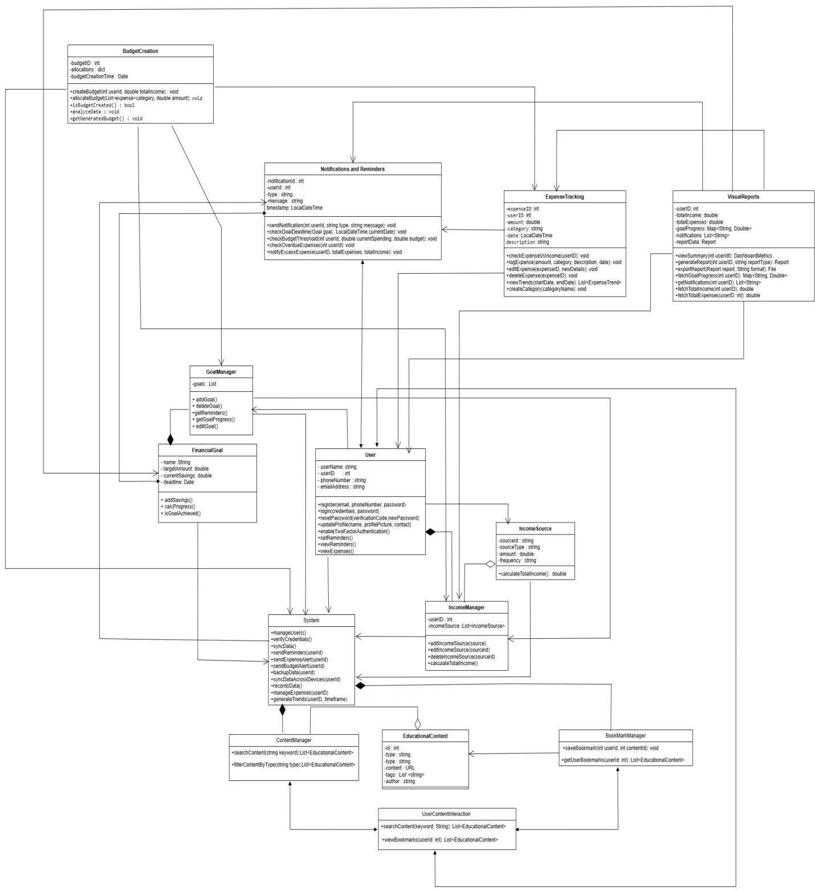

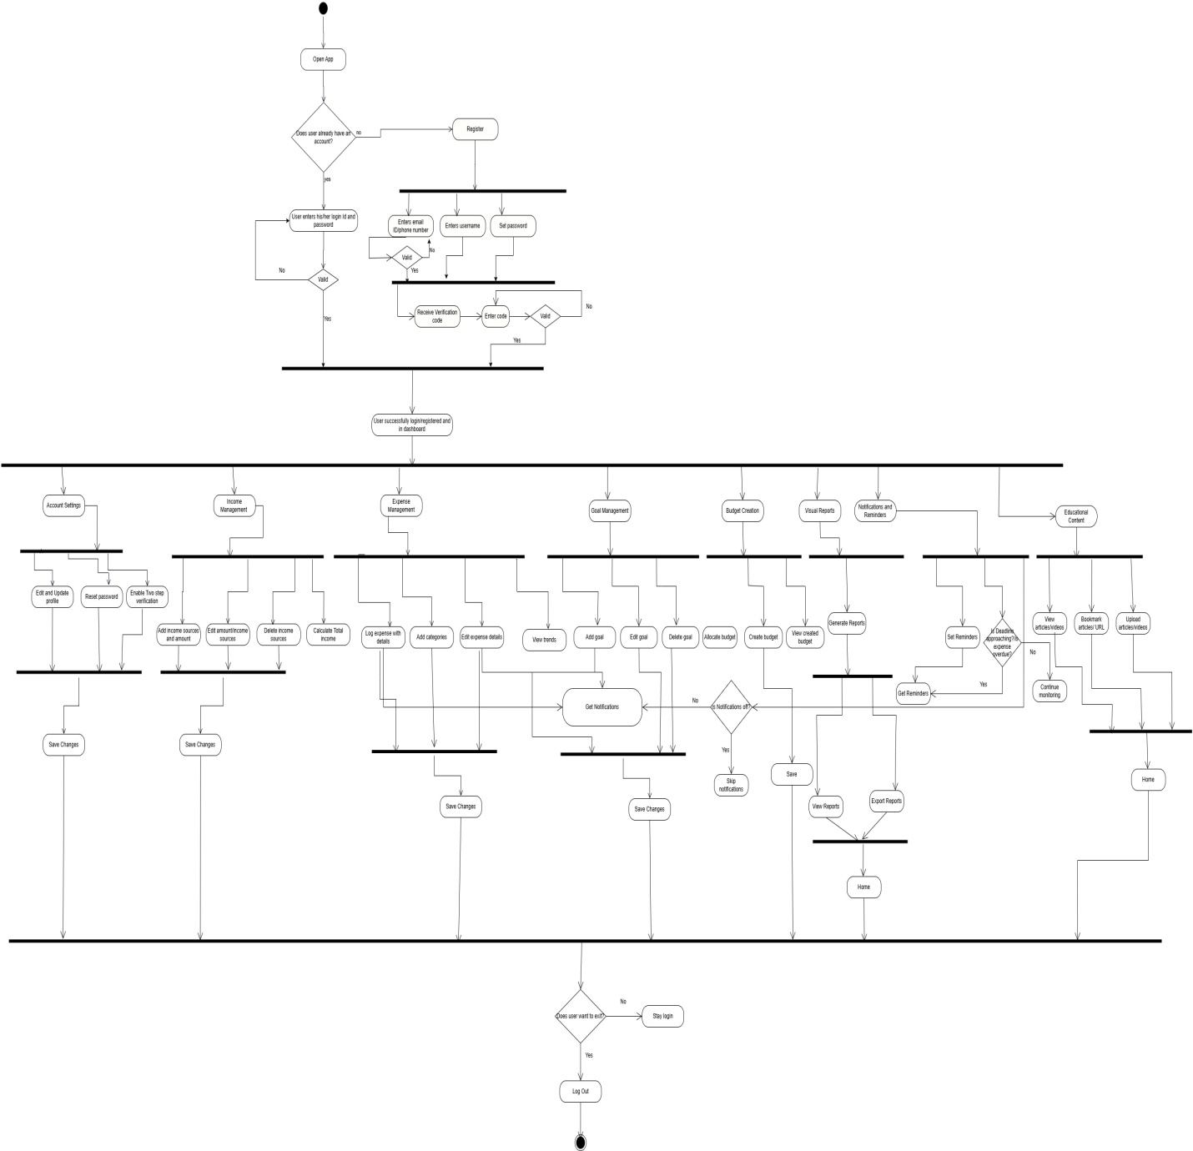

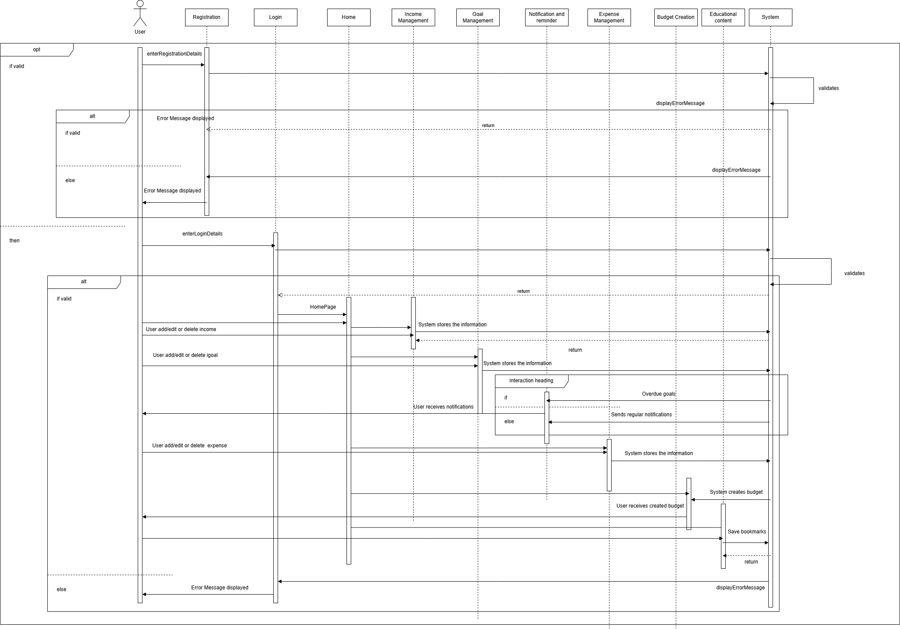

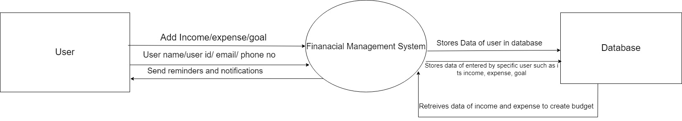

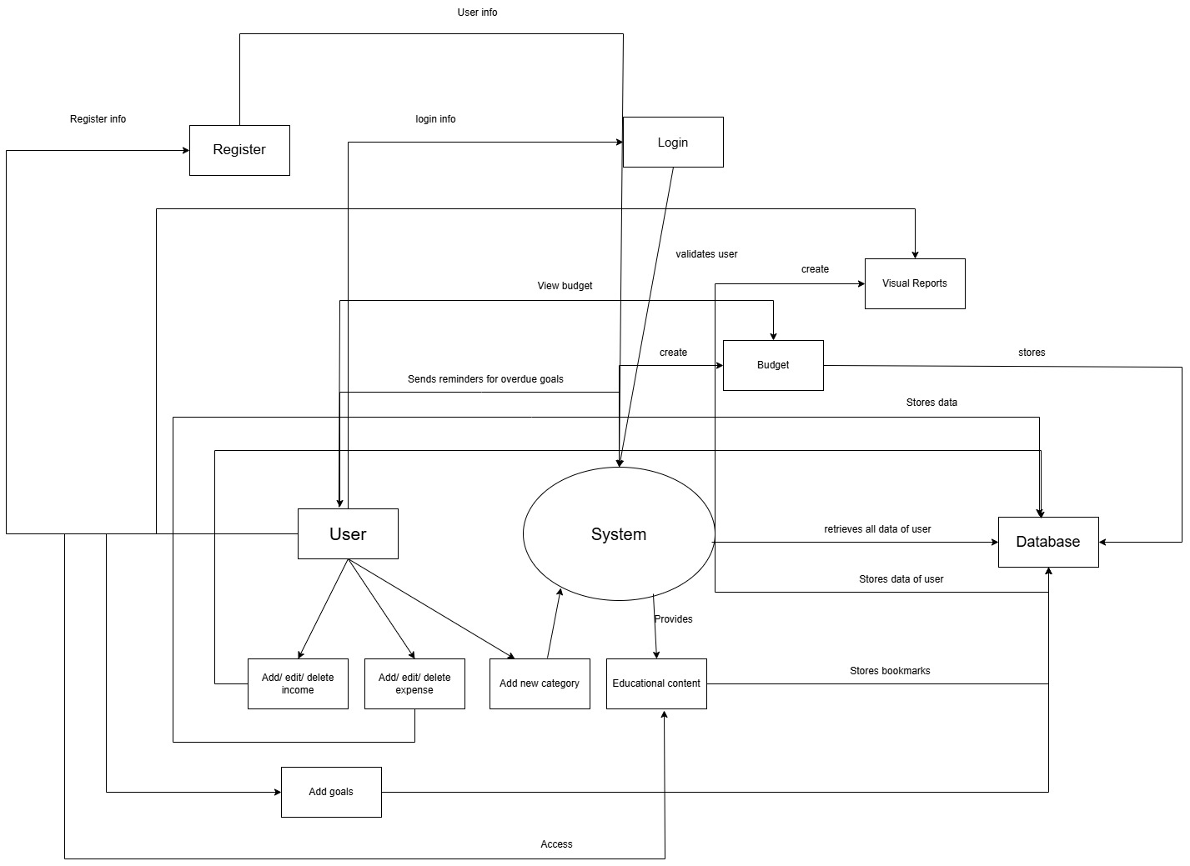 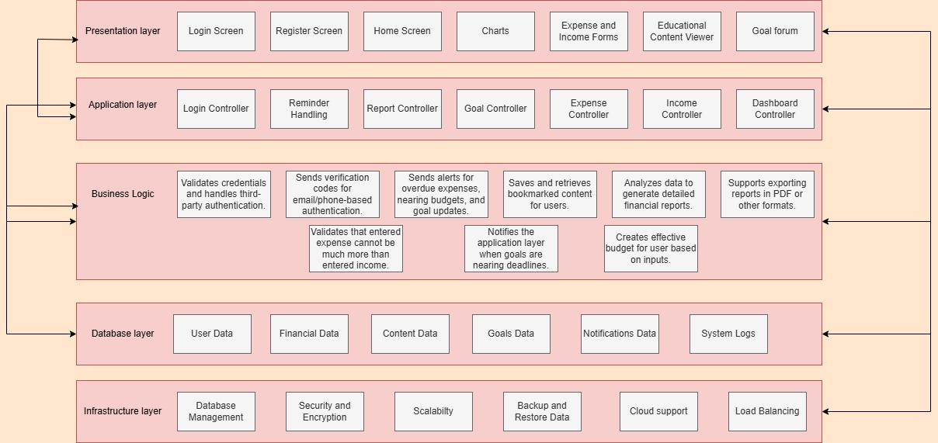

**Module Name: Register**

|  |  |  |  |  |  |  |  |  |  |  |  |  |
| --- | --- | --- | --- | --- | --- | --- | --- | --- | --- | --- | --- | --- |
| |  |  | | --- | --- | | **Test Case ID** | **register_01** | | **Test Case Description** | To test the account registration functionality for users to create an account with a valid email/phone and password. | | **Prerequisites** | 1. Stable internet connection. 2. Mobile device with the app installed. 3. User not already registered. | | **Tester's Name** | Rabia | | **Environmental Information** | 1. OS: Android/iOS 2. Device: Smartphone/Tablet. | | **Test Scenario** | Checking that users can register with a valid email/phone and password, handle errors for invalid formats, and verify the registration via email or phone. | |

|  |  |  |  |  |  |  |
| --- | --- | --- | --- | --- | --- | --- |
| **Test Case ID** | **Test Steps** | **Test Input** | **Expected Results** | **Actual Results** | **Status** | **Comments** |
| register_01.1 | Enter valid email and password | Email: [valid_email@example.com](mailto:valid_email@example.com) Password: valid_password | Account is created and a verification email/phone is sent | Account is created and verification email/phone is sent | Pass | No issues found. |
| register_01.2 | Enter invalid email format | Email: invalid_email Password: valid_password | Error message: "Invalid email format." | Error message: "Invalid email format." | Pass | Handled invalid email format. |
| register_01.3 | Enter valid phone number but invalid format | Phone: 12345 Password: valid_password | Error message: "Invalid phone number format." | Error message: "Invalid phone number format." | Pass | Handled invalid phone number format. |
| register_01.4 | Leave email/phone and password blank | Email: blank Password: blank | Error message: "Fields cannot be empty." | Error message: "Fields cannot be empty." | Pass | Empty input handled properly. |
| register_01.5 | Enter valid email and weak password | Email: [valid_email@example.com](mailto:valid_email@example.com) Password: weak_password | Error message: "Password is too weak." | Error message: "Password is too weak." | Pass | Handled weak password case. |
| register_01.6 | Attempt to register with already registered email/phone | Email: [already_registered@example.com](mailto:already_registered@example.com) Password: valid_password | Error message: "Email/Phone already registered." | Error message: "Email/Phone already registered." | Pass | Handled already registered email/phone case. |
| register_01.7 | Attempt registration without internet connection | Email: [valid_email@example.com](mailto:valid_email@example.com) Password: valid_password | Error message: "No internet connection." | Error message: "No internet connection." | Pass | Internet connection error displayed. |

**Module Name: Login**

|  |  |  |  |  |  |  |  |  |  |  |  |  |
| --- | --- | --- | --- | --- | --- | --- | --- | --- | --- | --- | --- | --- |
| |  |  | | --- | --- | | **Test Case ID** | **login_01** | | **Test Case Description** | To test the login functionality of the application. | | **Prerequisites** | 1. Stable internet connection. 2. Mobile device with the app installed. 3. Valid user account for testing. | | **Tester's Name** | Rabia | | **Environmental Information** | 1. OS: Android/iOS 2. Device: Smartphone/Tablet. | | **Test Scenario** | Checking that users can log in with correct credentials and are handled properly for incorrect credentials. | |

|  |  |  |  |  |  |  |
| --- | --- | --- | --- | --- | --- | --- |
| **Test Case ID** | **Test Steps** | **Test Input** | **Expected Results** | **Actual Results** | **Status** | **Comments** |
| login_01.1 | Enter valid username and password | Username: valid_user Password: valid_pass | User is redirected to the Home Dashboard. | User is redirected to the Home Dashboard. | Pass | No issues found. |
| login_01.2 | Enter invalid username and valid password | Username: invalid_user Password: valid_pass | Error message: "Invalid credentials." | Error message: "Invalid credentials." | Pass | Invalid credentials rejected successfully. |
| login_01.3 | Enter valid username and invalid password | Username: valid_user Password: invalid_pass | Error message: "Invalid credentials." | Error message: "Invalid credentials." | Pass | Invalid credentials rejected successfully. |
| login_01.4 | Leave both fields blank | Username: blank Password: blank | Error message: "Fields cannot be empty." | Error message: "Fields cannot be empty." | Pass | Empty input handled properly. |
| login_01.5 | Enter valid email but invalid format | Username: user@example Password: any_password | Error message: "Invalid email format." | Error message: "Invalid email format." | Pass | Invalid email format handled properly. |
| login_01.6 | Attempt login without internet connection | Username: valid_user Password: valid_pass | Error message: "No internet connection." | Error message: "No internet connection." | Pass | Internet connection error displayed. |

**Module Name: Third-Party Login**

|  |  |  |  |  |  |  |  |  |  |  |  |  |
| --- | --- | --- | --- | --- | --- | --- | --- | --- | --- | --- | --- | --- |
| |  |  | | --- | --- | | **Test Case ID** | **third_party_login_01** | | **Test Case Description** | To test the third-party authentication functionality (e.g., Google, Facebook) for users to log in via their third-party accounts. | | **Prerequisites** | 1. Stable internet connection. 2. Mobile device with the app installed. 3. Valid third-party account (Google, Facebook, etc.). | | **Tester's Name** | Rabia | | **Environmental Information** | 1. OS: Android/iOS 2. Device: Smartphone/Tablet. | | **Test Scenario** | Checking that users can successfully log in using third-party authentication (Google/Facebook) and that the login process integrates seamlessly with the app. | |

|  |  |  |  |  |  |  |  |  |  |  |  |  |  |  |  |  |  |  |  |  |  |  |  |  |  |  |  |  |  |  |  |  |  |  |  |  |  |  |  |  |  |  |  |  |  |  |  |  |  |  |  |  |  |  |  |  |
| --- | --- | --- | --- | --- | --- | --- | --- | --- | --- | --- | --- | --- | --- | --- | --- | --- | --- | --- | --- | --- | --- | --- | --- | --- | --- | --- | --- | --- | --- | --- | --- | --- | --- | --- | --- | --- | --- | --- | --- | --- | --- | --- | --- | --- | --- | --- | --- | --- | --- | --- | --- | --- | --- | --- | --- | --- |
| |  |  |  |  |  |  |  | | --- | --- | --- | --- | --- | --- | --- | | **Test Case ID** | **Test Steps** | **Test Input** | **Expected Results** | **Actual Results** | **Status** | **Comments** | | third_party_login_01.1 | Tap on the Google login button | Google account: valid_account | User is redirected to Google login page and logs in successfully. | User redirected to Google login page and logged in. | Pass | No issues found. | | third_party_login_01.2 | Tap on the Facebook login button | Facebook account: valid_account | User is redirected to Facebook login page and logs in successfully. | User redirected to Facebook login page and logged in. | Pass | No issues found. | | third_party_login_01.3 | Tap on the Google login button with invalid credentials | Google account: invalid_account | Error message: "Invalid Google credentials." | Error message: "Invalid Google credentials." | Pass | Handled invalid credentials properly. | | third_party_login_01.4 | Tap on the Facebook login button with invalid credentials | Facebook account: invalid_account | Error message: "Invalid Facebook credentials." | Error message: "Invalid Facebook credentials." | Pass | Handled invalid credentials properly. | | third_party_login_01.5 | Attempt login via Google without internet connection | Google account: valid_account | Error message: "No internet connection." | Error message: "No internet connection." | Pass | Internet connection error displayed. | | third_party_login_01.6 | Tap on the third-party login button and cancel login process | Google account: valid_account Facebook account: valid_account | User is returned to the login screen without logging in. | User returned to login screen without login. | Pass | Handled cancellation correctly. | | third_party_login_01.7 | Attempt login with third-party account linked to multiple apps | Google account: valid_account | User is prompted to choose an account and log in successfully. | User prompted to choose account and logged in. | Pass | Handled account selection correctly. | |

**Module Name: Forgot Password**

|  |  |
| --- | --- |
| **Test Case ID** | **forgot_password_01** |
| **Test Case Description** | To test the functionality of the password reset process via email or phone verification. |
| **Prerequisites** | 1. Stable internet connection. 2. Mobile device with the app installed. 3. Valid registered email or phone number for the user. |
| **Tester's Name** | Rabia |
| **Environmental Information** | 1. OS: Android/iOS 2. Device: Smartphone/Tablet. |
| **Test Scenario** | Checking the password reset functionality via email or phone number for a registered user and ensuring proper handling of incorrect or unregistered user details. |

|  |  |  |  |  |  |  |  |  |  |  |  |  |  |  |  |  |  |  |  |  |  |  |  |  |  |  |  |  |  |  |  |  |  |  |  |  |  |  |  |  |  |  |  |  |  |  |  |  |  |  |  |  |  |  |  |  |  |  |  |  |  |  |  |  |  |  |  |  |  |  |
| --- | --- | --- | --- | --- | --- | --- | --- | --- | --- | --- | --- | --- | --- | --- | --- | --- | --- | --- | --- | --- | --- | --- | --- | --- | --- | --- | --- | --- | --- | --- | --- | --- | --- | --- | --- | --- | --- | --- | --- | --- | --- | --- | --- | --- | --- | --- | --- | --- | --- | --- | --- | --- | --- | --- | --- | --- | --- | --- | --- | --- | --- | --- | --- | --- | --- | --- | --- | --- | --- | --- |
| |  |  |  |  |  |  |  | | --- | --- | --- | --- | --- | --- | --- | | **Test Case ID** | **Test Steps** | **Test Input** | **Expected Results** | **Actual Results** | **Status** | **Comments** | | forgot_password_01.1 | Enter valid registered email address for password reset | Email: [valid_user@example.com](mailto:valid_user@example.com) | Reset email sent to the user’s email address with a link to reset password. | Reset email sent successfully. | Pass | No issues found. | | forgot_password_01.2 | Enter valid registered phone number for password reset | Phone number: +1234567890 | Reset SMS sent to the user's phone number with a link to reset password. | Reset SMS sent successfully. | Pass | No issues found. | | forgot_password_01.3 | Enter unregistered email address | Email: [unregistered_user@example.com](mailto:unregistered_user@example.com) | Error message: "Email address not registered." | Error message: "Email address not registered." | Pass | Unregistered email handled properly. | | forgot_password_01.4 | Enter unregistered phone number | Phone number: +0987654321 | Error message: "Phone number not registered." | Error message: "Phone number not registered." | Pass | Unregistered phone number handled properly. | | forgot_password_01.5 | Enter invalid email format | Email: invalid_email_format | Error message: "Invalid email format." | Error message: "Invalid email format." | Pass | Invalid email format handled properly. | | forgot_password_01.6 | Enter email with no internet connection | Email: [valid_user@example.com](mailto:valid_user@example.com) | Error message: "No internet connection." | Error message: "No internet connection." | Pass | Internet connection error displayed. | | forgot_password_01.7 | Click on the reset link in the email/SMS | Reset link from email/SMS | User is redirected to the password reset screen to set a new password. | User redirected to password reset screen. | Pass | No issues found. | | forgot_password_01.8 | Enter new password and confirm password | New password: new_pass Confirm password: new_pass | Password updated successfully and user is redirected to the login screen. | Password updated successfully. | Pass | No issues found. | | forgot_password_01.9 | Enter new password and mismatched confirm password | New password: new_pass Confirm password: different_pass | Error message: "Passwords do not match." | Error message: "Passwords do not match." | Pass | Mismatch in password confirmation handled properly. | |

**Module Name: Update Profile**

|  |  |  |  |  |  |  |  |  |  |  |  |  |
| --- | --- | --- | --- | --- | --- | --- | --- | --- | --- | --- | --- | --- |
| |  |  | | --- | --- | | **Test Case ID** | **update_profile_01** | | **Test Case Description** | To test the functionality of updating a user's profile, including name, contact information, and profile picture. | | **Prerequisites** | 1. Stable internet connection. 2. Mobile device with the app installed. 3. User logged in with valid credentials. | | **Tester's Name** | Rabia | | **Environmental Information** | 1. OS: Android/iOS 2. Device: Smartphone/Tablet. | | **Test Scenario** | Checking that users can update their name, contact information, and profile picture, and ensuring the system validates the inputs correctly. | |

|  |  |  |  |  |  |  |
| --- | --- | --- | --- | --- | --- | --- |
| **Test Case ID** | **Test Steps** | **Test Input** | **Expected Results** | **Actual Results** | **Status** | **Comments** |
| update_profile_01.1 | Tap on the "Edit Profile" button | N/A | User is redirected to the profile update screen. | User redirected to profile update screen. | Pass | No issues found. |
| update_profile_01.2 | Update name field with a valid name | Name: John Doe | Name is updated successfully. | Name updated successfully. | Pass | No issues found. |
| update_profile_01.3 | Update phone number with a valid format | Phone number: +1234567890 | Phone number updated successfully. | Phone number updated successfully. | Pass | No issues found. |
| update_profile_01.4 | Update email with a valid email format | Email: [john.doe@example.com](mailto:john.doe@example.com) | Email updated successfully. | Email updated successfully. | Pass | No issues found. |
| update_profile_01.5 | Update profile picture with a valid image file | Profile picture: image_file.png | Profile picture updated successfully. | Profile picture updated successfully. | Pass | No issues found. |
| update_profile_01.6 | Update phone number with invalid format | Phone number: 12345 | Error message: "Invalid phone number format." | Error message: "Invalid phone number format." | Pass | Invalid phone number format handled properly. |
| update_profile_01.7 | Update email with invalid format | Email: invalid_email_format | Error message: "Invalid email format." | Error message: "Invalid email format." | Pass | Invalid email format handled properly. |
| update_profile_01.8 | Leave the name field empty | Name: (blank) | Error message: "Name cannot be empty." | Error message: "Name cannot be empty." | Pass | Empty name field handled properly. |
| update_profile_01.9 | Leave the phone number field empty | Phone number: (blank) | Error message: "Phone number cannot be empty." | Error message: "Phone number cannot be empty." | Pass | Empty phone number field handled properly. |
| update_profile_01.10 | Tap on "Save" after updating details | Name: John Doe Phone: +1234567890 Email: [john.doe@example.com](mailto:john.doe@example.com) Profile picture: image_file.png | User is redirected back to the profile screen with updated details. | User redirected to profile screen with updated details. | Pass | No issues found. |
| update_profile_01.11 | Attempt to update profile without internet connection | N/A | Error message: "No internet connection." | Error message: "No internet connection." | Pass | Internet connection error displayed. |

**Module Name: Account Security**

|  |  |  |  |  |  |  |  |  |  |  |  |  |
| --- | --- | --- | --- | --- | --- | --- | --- | --- | --- | --- | --- | --- |
| |  |  | | --- | --- | | **Test Case ID** | **account_security_01** | | **Test Case Description** | To verify the functionality of two-factor authentication (2FA) for secure login, including the correct handling of 2FA codes. | | **Prerequisites** | 1. Stable internet connection. 2. Mobile device with the app installed. 3. User logged in with valid credentials and 2FA enabled. | | **Tester's Name** | Rabia | | **Environmental Information** | 1. OS: Android/iOS 2. Device: Smartphone/Tablet. | | **Test Scenario** | Checking that two-factor authentication is triggered correctly after login and ensuring users can authenticate successfully using their second factor (e.g., SMS code, authentication app). | |

|  |  |  |  |  |  |  |
| --- | --- | --- | --- | --- | --- | --- |
| **Test Case ID** | **Test Steps** | **Test Input** | **Expected Results** | **Actual Results** | **Status** | **Comments** |
| account_security_01.1 | Enter valid username and password. | Username: valid_user Password: valid_pass | User is prompted for 2FA code. | User is prompted for 2FA code. | Pass | No issues found. |
| account_security_01.2 | Enter valid 2FA code received via SMS | 2FA Code: 123456 | User is successfully logged in and redirected to the home screen. | User successfully logged in. | Pass | No issues found. |
| account_security_01.3 | Enter invalid 2FA code | 2FA Code: 654321 | Error message: "Invalid 2FA code. Please try again." | Error message: "Invalid 2FA code." | Pass | Invalid code handled properly. |
| account_security_01.4 | Enter expired 2FA code | 2FA Code: (expired code) | Error message: "The code has expired. Please request a new one." | Error message: "The code has expired." | Pass | Expired code handled properly. |
| account_security_01.5 | Attempt login without internet connection | Username: valid_user Password: valid_pass | Error message: "No internet connection." | Error message: "No internet connection." | Pass | Internet connection error displayed. |
| account_security_01.6 | Enter valid username and password, but skip 2FA code | N/A | Error message: "2FA code is required to complete login." | Error message: "2FA code is required." | Pass | 2FA code requirement handled properly. |
| account_security_01.7 | Request a new 2FA code after failure | N/A | User receives a new 2FA code. | User receives new code. | Pass | New code generated successfully. |
| account_security_01.8 | Attempt to login with correct 2FA code after multiple failed attempts | 2FA Code: 123456 | User is prompted to wait before retrying or asked for a security question. | User prompted to wait. | Pass | Retry handling works. |
| account_security_01.9 | Log out and attempt login again with 2FA | Username: valid_user Password: valid_pass 2FA Code: 123456 | User successfully logs in and is redirected to home screen. | User successfully logged in. | Pass | Logout and login process works. |

**Module Name: Add Income Sources**

|  |  |  |  |  |  |  |  |  |  |  |  |  |
| --- | --- | --- | --- | --- | --- | --- | --- | --- | --- | --- | --- | --- |
| |  |  | | --- | --- | | **Test Case ID** | **add_income_sources_01** | | **Test Case Description** | To verify the functionality of adding income sources such as salary, freelance, and rental income, including details like amount, frequency, and source type. | | **Prerequisites** | 1. Stable internet connection. 2. Mobile device with the app installed. 3. User logged in with a valid account. | | **Tester's Name** | Rabia | | **Environmental Information** | 1. OS: Android/iOS 2. Device: Smartphone/Tablet. | | **Test Scenario** | Checking the ability to add different types of income sources with valid inputs and ensuring that the income source is saved correctly in the system. | |

|  |  |  |  |  |  |  |
| --- | --- | --- | --- | --- | --- | --- |
| **Test Case ID** | **Test Steps** | **Test Input** | **Expected Results** | **Actual Results** | **Status** | **Comments** |
| add_income_sources_01.1 | Enter valid salary income details. | Income Type: Salary Amount: 5000 Frequency: Monthly Source: Company A | Income source is successfully added and displayed in the income list. | Income source added successfully. | Pass | Salary income added correctly. |
| add_income_sources_01.2 | Enter valid freelance income details. | Income Type: Freelance Amount: 1500 Frequency: Weekly Source: Freelance Client | Income source is successfully added and displayed in the income list. | Income source added successfully. | Pass | Freelance income added correctly. |
| add_income_sources_01.3 | Enter valid rental income details. | Income Type: Rental Amount: 2000 Frequency: Monthly Source: Property A | Income source is successfully added and displayed in the income list. | Income source added successfully. | Pass | Rental income added correctly. |
| add_income_sources_01.4 | Enter invalid amount (negative value). | Income Type: Salary Amount: -5000 Frequency: Monthly Source: Company A | Error message: "Amount cannot be negative." | Error message displayed correctly. | Pass | Negative amount handled properly. |
| add_income_sources_01.5 | Leave frequency field empty. | Income Type: Freelance Amount: 1500 Frequency: (blank) Source: Freelance Client | Error message: "Frequency is required." | Error message displayed correctly. | Pass | Empty frequency field handled properly. |
| add_income_sources_01.6 | Enter valid details but choose an invalid income type. | Income Type: (invalid type) Amount: 1000 Frequency: Monthly Source: Client B | Error message: "Invalid income type selected." | Error message displayed correctly. | Pass | Invalid income type handled properly. |
| add_income_sources_01.7 | Enter valid details and submit with a source that already exists. | Income Type: Salary Amount: 3000 Frequency: Monthly Source: Company A | Error message: "Income source already exists." | Error message displayed correctly. | Pass | Duplicate source handled properly. |
| add_income_sources_01.8 | Enter valid details and save the income source. | Income Type: Other Amount: 1000 Frequency: One-time Source: Miscellaneous | Income source is successfully added and displayed in the income list. | Income source added successfully. | Pass | Miscellaneous income added correctly. |
| add_income_sources_01.9 | Try adding income source with no input in any field. | Income Type: (blank) Amount: (blank) Frequency: (blank) Source: (blank) | Error message: "All fields are required." | Error message displayed correctly. | Pass | All fields required handled properly. |
| add_income_sources_01.10 | Verify income source persistence after app restart. | Income Type: Freelance Amount: 2000 Frequency: Monthly Source: Freelance Client | Income source should still appear in the income list after restarting the app. | Income source persisted correctly. | Pass | Income source persisted correctly after restart. |

**Module Name: Edit Income**

|  |  |  |  |  |  |  |  |  |  |  |  |  |
| --- | --- | --- | --- | --- | --- | --- | --- | --- | --- | --- | --- | --- |
| |  |  | | --- | --- | | **Test Case ID** | **edit_income_01** | | **Test Case Description** | To verify the functionality of editing existing income sources, ensuring the correct modification of income details such as amount, frequency, and source type. | | **Prerequisites** | 1. Stable internet connection. 2. Mobile device with the app installed. 3. User logged in with a valid account. 4. Existing income sources added for editing. | | **Tester's Name** | Rabia | | **Environmental Information** | 1. OS: Android/iOS 2. Device: Smartphone/Tablet. | | **Test Scenario** | Checking the ability to edit income details for an existing income source and ensuring that the changes are saved correctly. | |

|  |  |  |  |  |  |  |
| --- | --- | --- | --- | --- | --- | --- |
| **Test Case ID** | **Test Steps** | **Test Input** | **Expected Results** | **Actual Results** | **Status** | **Comments** |
| edit_income_01.1 | Select an existing income source and click on 'Edit'. | Income Source: Freelance | The income details for the selected source are displayed for editing. | Income details displayed for editing. | Pass | Editing screen loaded correctly. |
| edit_income_01.2 | Modify the income amount. | New Amount: 1800 | The income amount is updated and saved correctly. | Income amount updated successfully. | Pass | Amount updated correctly. |
| edit_income_01.3 | Change the frequency of income. | New Frequency: Bi-weekly | The frequency of the income is updated and saved correctly. | Frequency updated successfully. | Pass | Frequency updated correctly. |
| edit_income_01.4 | Modify the source type (e.g., from "Freelance" to "Salary"). | New Source Type: Salary | The source type is updated correctly. | Source type updated successfully. | Pass | Source type updated correctly. |
| edit_income_01.5 | Leave income amount blank. | Income Type: Salary Amount: (blank) | Error message: "Amount is required." | Error message displayed correctly. | Pass | Blank amount handled properly. |
| edit_income_01.6 | Leave frequency field blank. | Income Type: Salary Amount: 3000 Frequency: (blank) | Error message: "Frequency is required." | Error message displayed correctly. | Pass | Blank frequency handled properly. |
| edit_income_01.7 | Edit income source to an already existing source (duplicate). | New Source: Freelance | Error message: "This income source already exists." | Error message displayed correctly. | Pass | Duplicate source handled correctly. |
| edit_income_01.8 | Cancel editing and return to the previous screen. | Income Type: Freelance Amount: 2000 Frequency: Weekly | No changes are saved, and the user is returned to the income list. | No changes saved. User returned to list. | Pass | Edit cancel functionality working correctly. |
| edit_income_01.9 | Save changes and verify the updated details are reflected in the income list. | Income Type: Freelance Amount: 1800 Frequency: Bi-weekly | Updated income source should appear in the income list with the new details. | Income source updated correctly in list. | Pass | Changes reflected correctly in the list. |
| edit_income_01.10 | Verify income source persistence after app restart. | Income Type: Freelance Amount: 1800 Frequency: Bi-weekly | Edited income source should persist after app restart. | Edited income source persisted correctly. | Pass | Changes persisted correctly after restart. |

**Module Name: Delete Income**

|  |  |  |  |  |  |  |  |  |  |  |  |  |
| --- | --- | --- | --- | --- | --- | --- | --- | --- | --- | --- | --- | --- |
| |  |  | | --- | --- | | **Test Case ID** | **delete_income_01** | | **Test Case Description** | To verify the functionality of deleting an existing income source and ensuring that the source is permanently removed from the system. | | **Prerequisites** | 1. Stable internet connection. 2. Mobile device with the app installed. 3. User logged in with a valid account. 4. Existing income sources added for deletion. | | **Tester's Name** | Rabia | | **Environmental Information** | 1. OS: Android/iOS 2. Device: Smartphone/Tablet. | | **Test Scenario** | Checking the ability to delete an income source and ensuring it is removed from the list and the data is updated correctly. | |

|  |  |  |  |  |  |  |
| --- | --- | --- | --- | --- | --- | --- |
| **Test Case ID** | **Test Steps** | **Test Input** | **Expected Results** | **Actual Results** | **Status** | **Comments** |
| delete_income_01.1 | Select an existing income source and click on 'Delete'. | Income Source: Freelance | The income source is marked for deletion. A confirmation prompt appears. | Deletion prompt appeared. | Pass | Prompt displayed correctly. |
| delete_income_01.2 | Confirm the deletion by selecting 'Yes'. | Confirmation: Yes | The selected income source is permanently deleted, and the list is updated. | Income source deleted and list updated. | Pass | Source deleted and list updated. |
| delete_income_01.3 | Select an income source and click 'Delete', then select 'No' to cancel. | Confirmation: No | No deletion occurs, and the user is returned to the income list. | No deletion, user returned to list. | Pass | Deletion cancelled successfully. |
| delete_income_01.4 | Attempt to delete an income source that is linked to a financial goal. | Income Source: Freelance (linked to goal) | Error message: "This income source is linked to a goal and cannot be deleted." | Error message displayed correctly. | Pass | Linked source handled properly. |
| delete_income_01.5 | Try to delete an income source while offline. | Income Source: Salary | Error message: "No internet connection." Deletion request cannot be processed. | Error message displayed correctly. | Pass | Offline error handled properly. |
| delete_income_01.6 | Check if the income source is removed from the list after deletion. | Income Source: Freelance | Income source should no longer appear in the income list. | Income source removed from list. | Pass | Source removed as expected. |
| delete_income_01.7 | Verify persistence of deletion after app restart. | Income Source: Freelance (deleted) | The deleted income source should not appear after restarting the app. | Deleted income source not present. | Pass | Deletion persisted after restart. |
| delete_income_01.8 | Attempt to delete a non-existing income source. | Income Source: Non-existent | Error message: "Income source not found." | Error message displayed correctly. | Pass | Non-existing source handled properly. |
| delete_income_01.9 | Check if the user is logged out or redirected after the deletion. | Income Source: Freelance | The user remains logged in and is not redirected. The app state remains unchanged. | User remains logged in. No redirection. | Pass | User session remains active. |

**Module Name: Categorization**

|  |  |  |  |  |  |  |  |  |  |  |  |  |
| --- | --- | --- | --- | --- | --- | --- | --- | --- | --- | --- | --- | --- |
| |  |  | | --- | --- | | **Test Case ID** | **categorization_01** | | **Test Case Description** | To verify the categorization functionality, including predefined categories such as rent, utilities, groceries, entertainment, and the ability for users to add custom categories. | | **Prerequisites** | 1. Stable internet connection. 2. Mobile device with the app installed. 3. User logged in with a valid account. | | **Tester's Name** | Rabia | | **Environmental Information** | 1. OS: Android/iOS 2. Device: Smartphone/Tablet. | | **Test Scenario** | Checking predefined categories, the ability to add custom categories, and ensuring they are saved and displayed properly. | |

|  |  |  |  |  |  |  |
| --- | --- | --- | --- | --- | --- | --- |
| **Test Case ID** | **Test Steps** | **Test Input** | **Expected Results** | **Actual Results** | **Status** | **Comments** |
| categorization_01.1 | Open the category section and view predefined categories. | Predefined Categories | Categories: Rent, Utilities, Groceries, Entertainment | Categories listed correctly. | Pass | Predefined categories displayed as expected. |
| categorization_01.2 | Add a new custom category. | Custom Category Name: "Travel" | Category "Travel" should be added and displayed in the list. | Custom category "Travel" added. | Pass | Category added as expected. |
| categorization_01.3 | Add another custom category with a duplicate name. | Custom Category Name: "Rent" | Error message: "Category name already exists." | Error message displayed. | Pass | Duplicate category handling works. |
| categorization_01.4 | Edit a custom category name. | Current Category: "Travel", New Name: "Holiday" | Category name should be updated to "Holiday" in the list. | Category name updated to "Holiday". | Pass | Category edited successfully. |
| categorization_01.5 | Delete a custom category. | Category Name: "Holiday" | Category should be removed from the list. | Category removed successfully. | Pass | Category deleted correctly. |
| categorization_01.6 | Try to delete a predefined category. | Predefined Category: "Groceries" | Error message: "Cannot delete predefined category." | Error message displayed. | Pass | Predefined categories protected from deletion. |
| categorization_01.7 | Check if custom categories are displayed after app restart. | Custom Category: "Travel" | Custom categories should be saved and displayed correctly after restarting the app. | Custom category "Travel" displayed after restart. | Pass | Custom categories persisted after restart. |
| categorization_01.8 | Verify that new custom categories can be used when adding an expense. | Custom Category: "Travel" | "Travel" should be available in the category dropdown when logging an expense. | "Travel" appears in the expense category list. | Pass | Custom category available for expense entry. |
| categorization_01.9 | Verify behavior when no category is selected while adding an expense. | Expense Category: None | Error message: "Category cannot be empty." | Error message displayed. | Pass | Empty category input handled properly. |
| categorization_01.10 | Check if the app allows for editing an existing predefined category. | Predefined Category: "Rent", New Name: "Housing" | Error message: "Cannot edit predefined category." | Error message displayed. | Pass | Predefined category editing restricted. |
| categorization_01.11 | Check if expense categories are synced across devices. | Category: "Travel" | "Travel" should be visible across all devices where the user is logged in. | "Travel" category visible across devices. | Pass | Category synchronization works as expected. |

**Module Name: Expense Entry**

|  |  |  |  |  |  |  |  |  |  |  |  |  |
| --- | --- | --- | --- | --- | --- | --- | --- | --- | --- | --- | --- | --- |
| |  |  | | --- | --- | | **Test Case ID** | **expense_entry_01** | | **Test Case Description** | To verify that expenses can be logged with the required details such as amount, date, and category. | | **Prerequisites** | 1. Stable internet connection. 2. Mobile device with the app installed. 3. User logged in with a valid account. | | **Tester's Name** | Rabia | | **Environmental Information** | 1. OS: Android/iOS 2. Device: Smartphone/Tablet. | | **Test Scenario** | Checking if the user can log expenses correctly by entering amount, date, and category, and verifying if they are saved and displayed properly. | |

|  |  |  |  |  |  |  |
| --- | --- | --- | --- | --- | --- | --- |
| **Test Case ID** | **Test Steps** | **Test Input** | **Expected Results** | **Actual Results** | **Status** | **Comments** |
| expense_entry_01.1 | Open the expense entry form. | None | Expense entry form should open. | Expense entry form opened. | Pass | Form opened successfully. |
| expense_entry_01.2 | Enter valid expense amount, date, and category. | Amount: 100, Date: 2025-01-18, Category: Groceries | Expense should be saved and shown in the expense list. | Expense saved and displayed. | Pass | Expense added correctly. |
| expense_entry_01.3 | Leave the amount field empty. | Amount: blank, Date: 2025-01-18, Category: Groceries | Error message: "Amount cannot be empty." | Error message displayed. | Pass | Empty amount handled properly. |
| expense_entry_01.4 | Leave the date field empty. | Amount: 100, Date: blank, Category: Groceries | Error message: "Date cannot be empty." | Error message displayed. | Pass | Empty date handled properly. |
| expense_entry_01.5 | Leave the category field empty. | Amount: 100, Date: 2025-01-18, Category: blank | Error message: "Category cannot be empty." | Error message displayed. | Pass | Empty category handled properly. |
| expense_entry_01.6 | Enter an invalid amount (negative number). | Amount: -50, Date: 2025-01-18, Category: Groceries | Error message: "Amount must be positive." | Error message displayed. | Pass | Invalid amount handled properly. |
| expense_entry_01.7 | Enter an invalid date format. | Amount: 100, Date: 2025/01/18, Category: Groceries | Error message: "Invalid date format." | Error message displayed. | Pass | Invalid date format handled. |
| expense_entry_01.8 | Enter valid expense details and submit the form. | Amount: 100, Date: 2025-01-18, Category: Groceries | Expense should be saved and shown in the expense list. | Expense saved and displayed. | Pass | Expense added and displayed correctly. |
| expense_entry_01.9 | Verify if the expense is reflected in the report. | Expense Entry: 100 on 2025-01-18 under Groceries | Expense should appear in the financial report for the date and category. | Expense reflected in the report. | Pass | Expense is included in the report. |
| expense_entry_01.10 | Verify if the expense is reflected across devices. | Expense Entry: 100 on 2025-01-18 under Groceries | Expense should appear on other devices upon syncing. | Expense displayed on other devices. | Pass | Expense sync works correctly. |
| expense_entry_01.11 | Try logging an expense without internet. | Amount: 100, Date: 2025-01-18, Category: Groceries | Error message: "No internet connection." | Error message displayed. | Pass | No internet error displayed. |
| expense_entry_01.12 | Verify if the expense is saved after restarting the app. | Expense Entry: 100 on 2025-01-18 under Groceries | Expense should be visible in the expense list after restarting the app. | Expense visible after restart. | Pass | Expense persisted after app restart. |
| expense_entry_01.13 | Enter an expense with a custom category. | Amount: 200, Date: 2025-01-18, Category: Travel | Expense should be saved and shown under the custom category. | Expense saved under "Travel". | Pass | Custom category used correctly. |
| expense_entry_01.14 | Verify that the amount entered is reflected correctly in the expense list. | Amount: 50, Date: 2025-01-18, Category: Groceries | Amount should be displayed correctly in the expense list. | Amount displayed as 50. | Pass | Amount displayed correctly. |

**Module Name: Delete Expense**

|  |  |  |  |  |  |  |  |  |  |  |  |  |
| --- | --- | --- | --- | --- | --- | --- | --- | --- | --- | --- | --- | --- |
| |  |  | | --- | --- | | **Test Case ID** | **delete_expense_01** | | **Test Case Description** | To verify that users can delete an expense from the expense list. | | **Prerequisites** | 1. Stable internet connection. 2. Mobile device with the app installed. 3. User logged in with a valid account. 4. At least one expense entry exists in the system. | | **Tester's Name** | Rabia | | **Environmental Information** | 1. OS: Android/iOS 2. Device: Smartphone/Tablet. | | **Test Scenario** | Checking if users can delete an expense and if the system reflects the deletion correctly. | |

|  |  |  |  |  |  |  |
| --- | --- | --- | --- | --- | --- | --- |
| **Test Case ID** | **Test Steps** | **Test Input** | **Expected Results** | **Actual Results** | **Status** | **Comments** |
| delete_expense_01.1 | Open the expense list. | None | Expense list should open. | Expense list opened. | Pass | List opened successfully. |
| delete_expense_01.2 | Select an expense from the list. | Expense: 100 on 2025-01-18 under Groceries | Expense should be selected. | Expense selected. | Pass | Expense selected correctly. |
| delete_expense_01.3 | Click the delete button for the selected expense. | Expense selected: 100 on 2025-01-18 under Groceries | Expense should be deleted from the list. | Expense deleted from the list. | Pass | Expense deleted successfully. |
| delete_expense_01.4 | Verify the expense is deleted from the list. | Expense: 100 on 2025-01-18 under Groceries | Expense should no longer be displayed in the list. | Expense not found in the list. | Pass | Expense deletion confirmed. |
| delete_expense_01.5 | Try deleting an expense without internet connection. | Expense selected: 100 on 2025-01-18 under Groceries | Error message: "No internet connection." | Error message displayed. | Pass | No internet error displayed. |
| delete_expense_01.6 | Verify that the deleted expense is removed after restarting the app. | Expense: 100 on 2025-01-18 under Groceries | Expense should not appear in the list after restarting the app. | Expense not visible after restart. | Pass | Expense deletion persisted after restart. |
| delete_expense_01.7 | Attempt to delete an expense that does not exist. | Expense selected: Non-existent expense | Error message: "Expense not found." | Error message displayed. | Pass | Error for non-existent expense handled properly. |
| delete_expense_01.8 | Verify that the total expense amount updates after deleting an expense. | Expense deleted: 100 on 2025-01-18 under Groceries | Total expense amount should decrease by 100. | Total expense amount updated correctly. | Pass | Total updated correctly. |
| delete_expense_01.9 | Try deleting an expense with a custom category. | Expense: 200 on 2025-01-18 under Travel | Expense should be deleted from the custom category. | Expense deleted from the custom category. | Pass | Custom category deletion handled correctly. |

**Module Name: Goal Creation**

|  |  |  |  |  |  |  |  |  |  |  |  |  |
| --- | --- | --- | --- | --- | --- | --- | --- | --- | --- | --- | --- | --- |
| |  |  | | --- | --- | | **Test Case ID** | **goal_creation_01** | | **Test Case Description** | To verify that users can set specific financial goals, including entering the target amount and deadline for the goal. | | **Prerequisites** | 1. Stable internet connection. 2. Mobile device with the app installed. 3. User logged in with a valid account. | | **Tester's Name** | Rabia | | **Environmental Information** | 1. OS: Android/iOS 2. Device: Smartphone/Tablet. | | **Test Scenario** | Checking that users can create a financial goal with valid target amount and deadline. | |

|  |  |  |  |  |  |  |
| --- | --- | --- | --- | --- | --- | --- |
| **Test Case ID** | **Test Steps** | **Test Input** | **Expected Results** | **Actual Results** | **Status** | **Comments** |
| goal_creation_01.1 | Open the "Create Goal" screen. | None | Goal creation screen should appear. | Goal creation screen appeared. | Pass | Screen appeared as expected. |
| goal_creation_01.2 | Enter valid goal details (target amount and deadline). | Target amount: 5000, Deadline: 2025-12-31 | Goal details should be entered in the respective fields. | Goal details entered correctly. | Pass | Details entered successfully. |
| goal_creation_01.3 | Click "Save" to save the goal. | Goal details: 5000, Deadline: 2025-12-31 | Goal should be saved and appear in the list of goals. | Goal saved and displayed in list. | Pass | Goal saved and displayed correctly. |
| goal_creation_01.4 | Verify the goal is listed with correct details. | Goal: 5000 for 2025-12-31 | Created goal should appear in the goal list with target amount and deadline. | Goal listed with correct details. | Pass | Goal displayed correctly in the list. |
| goal_creation_01.5 | Enter invalid goal details (e.g., negative target amount). | Target amount: -1000, Deadline: 2025-12-31 | Error message: "Invalid target amount." | Error message displayed. | Pass | Invalid target amount rejected successfully. |
| goal_creation_01.6 | Leave required fields blank and try to save. | No input provided | Error message: "All fields are required." | Error message displayed. | Pass | Missing fields handled correctly. |
| goal_creation_01.7 | Enter a deadline in the past. | Target amount: 5000, Deadline: 2020-12-31 | Error message: "Deadline must be in the future." | Error message displayed. | Pass | Past deadline rejected successfully. |
| goal_creation_01.8 | Verify if the created goal remains saved after restarting the app. | Goal: 5000 for 2025-12-31 | Goal should remain saved after restarting the app. | Goal persists after restart. | Pass | Data persistence verified. |
| goal_creation_01.9 | Try creating a goal with a custom category. | Target amount: 3000, Deadline: 2025-06-30, Category: Vacation | Goal with custom category should be created successfully. | Goal with custom category saved. | Pass | Custom category handled correctly. |
| goal_creation_01.10 | Attempt to create a goal without internet connection. | Goal: 5000, Deadline: 2025-12-31 | Error message: "No internet connection." | Error message displayed. | Pass | Error for no internet connection handled correctly. |

**Module Name: Edit Goal**

|  |  |  |  |  |  |  |  |  |  |  |  |  |
| --- | --- | --- | --- | --- | --- | --- | --- | --- | --- | --- | --- | --- |
| |  |  | | --- | --- | | **Test Case ID** | **goal_edit_01** | | **Test Case Description** | To verify that users can edit the details of an existing financial goal, including updating the target amount, deadline, and category. | | **Prerequisites** | 1. Stable internet connection. 2. Mobile device with the app installed. 3. User logged in with a valid account. 4. At least one financial goal already created. | | **Tester's Name** | Rabia | | **Environmental Information** | 1. OS: Android/iOS 2. Device: Smartphone/Tablet. | | **Test Scenario** | Checking that users can successfully edit the target amount, deadline, and category of an existing goal. | |

|  |  |  |  |  |  |  |
| --- | --- | --- | --- | --- | --- | --- |
| **Test Case ID** | **Test Steps** | **Test Input** | **Expected Results** | **Actual Results** | **Status** | **Comments** |
| goal_edit_01.1 | Navigate to the "Edit Goal" screen. | Select an existing goal. | Goal editing screen should appear with current goal details. | Goal editing screen appeared with correct details. | Pass | Screen appeared as expected. |
| goal_edit_01.2 | Update the target amount. | New Target Amount: 6000 | Target amount should be updated to the new value. | Target amount updated correctly. | Pass | Amount updated as expected. |
| goal_edit_01.3 | Update the deadline. | New Deadline: 2026-12-31 | Deadline should be updated to the new value. | Deadline updated correctly. | Pass | Deadline updated as expected. |
| goal_edit_01.4 | Update the category. | New Category: Vacation Fund | Category should be updated to the new value. | Category updated correctly. | Pass | Category updated as expected. |
| goal_edit_01.5 | Save the edited goal. | Updated Goal: 6000 for 2026-12-31, Category: Vacation Fund | Goal should be saved and reflected in the goal list with updated details. | Goal saved with updated details. | Pass | Goal saved correctly with updated details. |
| goal_edit_01.6 | Attempt to update the goal with invalid data (e.g., negative target amount). | Target Amount: -2000, Deadline: 2026-12-31 | Error message: "Invalid target amount." | Error message displayed. | Pass | Invalid target amount rejected correctly. |
| goal_edit_01.7 | Leave required fields blank and try to save. | No input provided. | Error message: "All fields are required." | Error message displayed. | Pass | Blank fields handled properly. |
| goal_edit_01.8 | Attempt to set a deadline in the past. | Target Amount: 6000, Deadline: 2020-12-31 | Error message: "Deadline must be in the future." | Error message displayed. | Pass | Past deadline rejected successfully. |
| goal_edit_01.9 | Verify if the edited goal persists after restarting the app. | Edited Goal: 6000 for 2026-12-31 | Goal should persist with the updated details after restarting the app. | Goal persists with updated details after restart. | Pass | Persistence of edited goal verified. |
| goal_edit_01.10 | Try editing a goal without internet connection. | Target Amount: 6000, Deadline: 2026-12-31 | Error message: "No internet connection." | Error message displayed. | Pass | Error for no internet connection handled correctly. |

**Module Name: Delete Goal**

|  |  |  |  |  |  |  |  |  |  |  |  |  |
| --- | --- | --- | --- | --- | --- | --- | --- | --- | --- | --- | --- | --- |
| |  |  | | --- | --- | | **Test Case ID** | **goal_delete_01** | | **Test Case Description** | To verify that users can delete an existing financial goal and that it is removed from the system. | | **Prerequisites** | 1. Stable internet connection. 2. Mobile device with the app installed. 3. User logged in with a valid account. 4. At least one financial goal already created. | | **Tester's Name** | Rabia | | **Environmental Information** | 1. OS: Android/iOS 2. Device: Smartphone/Tablet. | | **Test Scenario** | Checking that users can successfully delete a financial goal and that the goal is removed from the goal list. | |

|  |  |  |  |  |  |  |
| --- | --- | --- | --- | --- | --- | --- |
| **Test Case ID** | **Test Steps** | **Test Input** | **Expected Results** | **Actual Results** | **Status** | **Comments** |
| goal_delete_01.1 | Navigate to the "Goals" screen. | Select an existing goal. | Goal details should be displayed. | Goal details displayed. | Pass | Goal list loaded correctly. |
| goal_delete_01.2 | Click on the delete option for a goal. | Select goal: "Vacation Fund" | Goal should be marked for deletion. | Goal marked for deletion. | Pass | Goal selected for deletion. |
| goal_delete_01.3 | Confirm deletion. | Confirm deletion action. | Goal should be permanently deleted from the list. | Goal deleted successfully. | Pass | Goal deleted as expected. |
| goal_delete_01.4 | Verify that the goal is no longer in the goal list after deletion. | - | Goal should not appear in the goal list. | Goal removed from the list. | Pass | Goal removed successfully from the list. |
| goal_delete_01.5 | Attempt to delete a goal with missing internet connection. | Select goal to delete, confirm deletion. | Error message: "No internet connection." | Error message displayed. | Pass | Error for no internet connection handled correctly. |
| goal_delete_01.6 | Try to delete a goal that doesn’t exist. | Select non-existent goal. | Error message: "Goal not found." | Error message displayed. | Pass | Non-existent goal handled properly. |
| goal_delete_01.7 | Verify if the deleted goal is completely removed from the system after app restart. | - | Goal should not be present after restarting the app. | Goal is not present after restart. | Pass | Goal correctly removed after restart. |
| goal_delete_01.8 | Attempt to delete a goal with invalid data (e.g., incomplete data). | Select goal with incomplete data. | Error message: "Invalid goal data." | Error message displayed. | Pass | Invalid goal data rejected correctly. |

**Module Name: Create Budget**

|  |  |  |  |  |  |  |  |  |  |  |  |  |
| --- | --- | --- | --- | --- | --- | --- | --- | --- | --- | --- | --- | --- |
| |  |  | | --- | --- | | **Test Case ID** | **budget_create_01** | | **Test Case Description** | To verify that the system correctly creates a budget for the user based on income, expenses, and financial goals. | | **Prerequisites** | 1. Stable internet connection. 2. Mobile device with the app installed. 3. User logged in with a valid account. 4. User has inputted income and expenses. | | **Tester's Name** | Rabia | | **Environmental Information** | 1. OS: Android/iOS 2. Device: Smartphone/Tablet. | | **Test Scenario** | Verifying that the system can create and display a budget for the user based on the financial data entered (income, expenses, goals). | |

|  |  |  |  |  |  |  |
| --- | --- | --- | --- | --- | --- | --- |
| **Test Case ID** | **Test Steps** | **Test Input** | **Expected Results** | **Actual Results** | **Status** | **Comments** |
| budget_create_01.1 | Navigate to the "Budget" screen. | - | Budget creation option should be visible. | Budget creation option visible. | Pass | Budget creation option accessible. |
| budget_create_01.2 | Click on "Create Budget" button. | - | The system should start processing the budget creation. | Budget creation started. | Pass | Budget creation started successfully. |
| budget_create_01.3 | Enter income data (e.g., salary, freelance). | Salary: $3000, Freelance: $1000 | Income details entered successfully. | Income entered successfully. | Pass | Income entered correctly. |
| budget_create_01.4 | Enter expense data (e.g., rent, utilities). | Rent: $800, Utilities: $200 | Expense details entered successfully. | Expense entered successfully. | Pass | Expenses entered correctly. |
| budget_create_01.5 | Enter financial goals (e.g., saving for vacation). | Goal: Vacation, Target Amount: $2000, Deadline: 6 months | Goal data entered successfully. | Goal entered successfully. | Pass | Goal entered correctly. |
| budget_create_01.6 | Click "Generate Budget" button after entering details. | - | The system should generate a budget based on income, expenses, and goals. | Budget generated successfully. | Pass | Budget created as expected. |
| budget_create_01.7 | Verify that the generated budget shows accurate allocations based on income, expenses, and goals. | Income: $4000, Expenses: $1000, Goals: $2000 | Budget should reflect income, expenses, and goal amounts. | Budget reflects income, expenses, and goals correctly. | Pass | Budget values are correct. |
| budget_create_01.8 | Check that the budget summary is displayed with categories like total income, total expenses, and savings. | - | Budget summary should display income, expenses, savings. | Budget summary displayed with all categories. | Pass | Summary displayed correctly. |
| budget_create_01.9 | Verify if the budget can be edited after creation. | Edit income/expenses. | The system should allow edits to the created budget. | Budget edited successfully. | Pass | Budget edited as expected. |
| budget_create_01.10 | Verify if the budget is saved and retained after app restart. | - | Budget should be retained after restarting the app. | Budget saved and retained. | Pass | Budget retained correctly. |
| budget_create_01.11 | Attempt to create a budget with missing income or expense data. | Missing income or expense. | Error message: "Income/Expense data missing." | Error message displayed. | Pass | Missing data error handled. |
| budget_create_01.12 | Try to create a budget without a valid internet connection. | - | Error message: "No internet connection." | Error message displayed. | Pass | Internet connection error handled. |

**Module Name: View Articles and Videos**

|  |  |  |  |  |  |  |  |  |  |  |  |  |
| --- | --- | --- | --- | --- | --- | --- | --- | --- | --- | --- | --- | --- |
| |  |  | | --- | --- | | **Test Case ID** | **articles_videos_view_01** | | **Test Case Description** | To verify that users can view articles and watch videos with effective tips within the app. | | **Prerequisites** | 1. Stable internet connection. 2. Mobile device with the app installed. 3. User logged in with a valid account. | | **Tester's Name** | Rabia | | **Environmental Information** | 1. OS: Android/iOS 2. Device: Smartphone/Tablet. | | **Test Scenario** | Verifying that users can view articles and videos for financial tips and advice, ensuring proper content display. | |

|  |  |  |  |  |  |  |
| --- | --- | --- | --- | --- | --- | --- |
| **Test Case ID** | **Test Steps** | **Test Input** | **Expected Results** | **Actual Results** | **Status** | **Comments** |
| articles_videos_view_01.1 | Navigate to the "Articles & Videos" section. | - | The section containing articles and videos should be displayed. | Articles and videos section displayed. | Pass | Section visible and accessible. |
| articles_videos_view_01.2 | Click on an article to read. | Article title: "Budgeting Tips for Beginners" | The article should open and display its content. | Article opened and content displayed. | Pass | Article displayed as expected. |
| articles_videos_view_01.3 | Click on a video to watch. | Video title: "Saving for Retirement" | The video player should open, and the video should play. | Video played successfully. | Pass | Video played without issues. |
| articles_videos_view_01.4 | Scroll through the list of available articles. | - | The list of articles should be scrollable and show more articles as needed. | Article list is scrollable. | Pass | Scrolling works fine. |
| articles_videos_view_01.5 | Scroll through the list of available videos. | - | The list of videos should be scrollable and show more videos as needed. | Video list is scrollable. | Pass | Scrolling works fine. |
| articles_videos_view_01.6 | Verify that the article content includes proper formatting (headings, paragraphs, etc.). | - | Article content should be formatted correctly, with headings, paragraphs, etc. | Article formatting is correct. | Pass | Article is formatted as expected. |
| articles_videos_view_01.7 | Verify that the video player has basic controls (play, pause, volume, full-screen). | - | Video player should have play, pause, volume control, and full-screen option. | Video player controls available. | Pass | Controls working correctly. |
| articles_videos_view_01.8 | Try to view an article or video with no internet connection. | - | Error message: "No internet connection." | Error message displayed. | Pass | Handled no internet scenario. |
| articles_videos_view_01.9 | Verify that the article or video is fully loaded and viewable without interruptions. | - | The content should load completely without interruption. | Article/video loaded completely. | Pass | Content loaded without issues. |
| articles_videos_view_01.10 | Attempt to access an article or video with missing content or errors. | - | Error message: "Content unavailable." | Error message displayed. | Pass | Error handling for missing content. |
| articles_videos_view_01.11 | Try viewing an article or video with a slow internet connection. | - | The article or video should buffer and display properly. | Article/video buffered and displayed. | Pass | Content buffered as expected. |

**Module Name: Bookmark Sources**

|  |  |  |  |  |  |  |  |  |  |  |  |  |
| --- | --- | --- | --- | --- | --- | --- | --- | --- | --- | --- | --- | --- |
| |  |  | | --- | --- | | **Test Case ID** | **bookmark_sources_01** | | **Test Case Description** | To verify that users can bookmark articles and videos for easy access later. | | **Prerequisites** | 1. Stable internet connection. 2. Mobile device with the app installed. 3. User logged in with a valid account. | | **Tester's Name** | Rabia | | **Environmental Information** | 1. OS: Android/iOS 2. Device: Smartphone/Tablet. | | **Test Scenario** | Verifying that users can successfully bookmark articles and videos and access them from the bookmark section. | |

|  |  |  |  |  |  |  |
| --- | --- | --- | --- | --- | --- | --- |
| **Test Case ID** | **Test Steps** | **Test Input** | **Expected Results** | **Actual Results** | **Status** | **Comments** |
| bookmark_sources_01.1 | Navigate to the "Articles & Videos" section. | - | The section containing articles and videos should be displayed. | Section displayed. | Pass | Section accessible. |
| bookmark_sources_01.2 | Select an article or video to bookmark. | Article title: "Budgeting Tips" | Bookmark icon should be visible on the article/video. | Bookmark icon visible. | Pass | Bookmark icon visible. |
| bookmark_sources_01.3 | Click the bookmark icon on an article/video. | Article/video selected | The article/video should be added to the "Bookmarked" section. | Article/video added to bookmarks. | Pass | Bookmark functionality works. |
| bookmark_sources_01.4 | Navigate to the "Bookmarked" section. | - | The bookmarked articles and videos should be listed here. | Bookmarked content listed. | Pass | Bookmarked content displayed correctly. |
| bookmark_sources_01.5 | Click on a bookmarked article or video. | Bookmarked article/video | The article or video should open and display its content. | Article/video opened correctly. | Pass | Opened from bookmarks without issues. |
| bookmark_sources_01.6 | Try bookmarking the same article/video multiple times. | Article/video title: "Saving for Retirement" | The article/video should only be bookmarked once. Duplicate bookmarking should not occur. | Only one bookmark created. | Pass | Duplicate bookmarking prevented. |
| bookmark_sources_01.7 | Remove an article/video from the "Bookmarked" section. | Article/video in bookmarks | The article/video should be removed from the "Bookmarked" section. | Article/video removed. | Pass | Bookmark removal works correctly. |
| bookmark_sources_01.8 | Attempt to bookmark an article/video with no internet connection. | - | Error message: "No internet connection." | Error message displayed. | Pass | Error handling for no internet connection. |
| bookmark_sources_01.9 | Verify that bookmarked articles/videos are available after app restart. | - | The bookmarked articles/videos should persist after restarting the app. | Bookmarked content available after restart. | Pass | Persistence tested successfully. |
| bookmark_sources_01.10 | Verify that the number of bookmarks is correctly updated after bookmarking/removing content. | - | The bookmark count should reflect accurately when items are added or removed. | Bookmark count updated. | Pass | Bookmark count accurate. |

**Module Name: Access Bookmarks**

|  |  |  |  |  |  |  |  |  |  |  |  |  |
| --- | --- | --- | --- | --- | --- | --- | --- | --- | --- | --- | --- | --- |
| |  |  | | --- | --- | | **Test Case ID** | **access_bookmarks_01** | | **Test Case Description** | To verify that users can access their bookmarked articles and videos. | | **Prerequisites** | 1. Stable internet connection. 2. Mobile device with the app installed. 3. User logged in with a valid account. 4. At least one article or video has been bookmarked. | | **Tester's Name** | Rabia | | **Environmental Information** | 1. OS: Android/iOS 2. Device: Smartphone/Tablet. | | **Test Scenario** | Verifying that users can access their bookmarked articles and videos from the "Bookmarked" section. | |

|  |  |  |  |  |  |  |
| --- | --- | --- | --- | --- | --- | --- |
| **Test Case ID** | **Test Steps** | **Test Input** | **Expected Results** | **Actual Results** | **Status** | **Comments** |
| access_bookmarks_01.1 | Navigate to the "Bookmarked" section. | - | The section containing all bookmarked articles and videos should be displayed. | Bookmarked section displayed. | Pass | Bookmarked content is visible. |
| access_bookmarks_01.2 | Click on a bookmarked article/video. | Bookmarked article/video title: "Budgeting Tips" | The article/video should open and display its content. | Article/video opened correctly. | Pass | Opened from the bookmarked list. |
| access_bookmarks_01.3 | Verify that a recently bookmarked article/video appears in the "Bookmarked" section. | Article/video just bookmarked | The article/video should immediately appear in the "Bookmarked" section. | New bookmark displayed immediately. | Pass | Bookmark appears instantly. |
| access_bookmarks_01.4 | Remove an article/video from the "Bookmarked" section. | Bookmarked article/video title: "Saving for Retirement" | The article/video should be removed from the "Bookmarked" section. | Article/video removed. | Pass | Removed from bookmarks. |
| access_bookmarks_01.5 | Attempt to access a bookmarked article/video after it has been removed. | Article/video removed previously | Error message: "This bookmark is no longer available." | Error message displayed. | Pass | Correct message displayed for removed items. |
| access_bookmarks_01.6 | Verify that the "Bookmarked" section remains accessible even after restarting the app. | - | The "Bookmarked" section and its contents should be available after the app is restarted. | Bookmarked section available post-restart. | Pass | Persistence works as expected. |
| access_bookmarks_01.7 | Verify that the number of bookmarks is correctly updated after adding/removing items. | - | The bookmark count should reflect the correct number after items are added or removed. | Bookmark count updated. | Pass | Bookmark count accurate. |
| access_bookmarks_01.8 | Attempt to access bookmarks with no internet connection. | - | Error message: "No internet connection." | Error message displayed. | Pass | Proper error handling for no internet connection. |

**Module Name: Upload Articles/Videos**

|  |  |  |  |  |  |  |  |  |  |  |  |  |
| --- | --- | --- | --- | --- | --- | --- | --- | --- | --- | --- | --- | --- |
| |  |  | | --- | --- | | **Test Case ID** | **upload_articles_videos_01** | | **Test Case Description** | To verify that users can upload articles or videos to the system. | | **Prerequisites** | 1. Stable internet connection. 2. Mobile device with the app installed. 3. User logged in with a valid account. 4. User has necessary permissions to upload articles or videos. | | **Tester's Name** | Rabia | | **Environmental Information** | 1. OS: Android/iOS 2. Device: Smartphone/Tablet. | | **Test Scenario** | Verifying that users can upload articles or videos successfully. | |

|  |  |  |  |  |  |  |
| --- | --- | --- | --- | --- | --- | --- |
| **Test Case ID** | **Test Steps** | **Test Input** | **Expected Results** | **Actual Results** | **Status** | **Comments** |
| upload_articles_videos_01.1 | Navigate to the "Upload" section. | - | The upload page/section should open. | Upload section displayed. | Pass | Page opened successfully. |
| upload_articles_videos_01.2 | Select the type of content to upload (Article/Video). | Option selected: "Article" | The system should allow uploading an article. | Article upload option shown. | Pass | Selection displayed correctly. |
| upload_articles_videos_01.3 | Upload a valid article (text or file). | Article title: "Saving Tips" Article content: "Tips for better savings." | The article should be uploaded successfully. | Article uploaded successfully. | Pass | Article uploaded and available in the system. |
| upload_articles_videos_01.4 | Upload a valid video (video file). | Video title: "How to Budget" Video file: "budgeting.mp4" | The video should be uploaded successfully. | Video uploaded successfully. | Pass | Video uploaded and playable. |
| upload_articles_videos_01.5 | Try to upload an unsupported file type (e.g., PDF when expecting video). | File: "document.pdf" | Error message: "Invalid file type. Please upload a supported file." | Error message displayed. | Pass | Error message shown for unsupported file types. |
| upload_articles_videos_01.6 | Upload an article without required fields (e.g., title or content missing). | Article title: "" Article content: "" | Error message: "Title and content are required." | Error message displayed. | Pass | Proper validation for missing fields. |
| upload_articles_videos_01.7 | Upload a video with a large file size that exceeds the system limit. | File: "large_video.mp4" (above size limit) | Error message: "File size exceeds limit." | Error message displayed. | Pass | System handles file size limit properly. |
| upload_articles_videos_01.8 | Attempt to upload content without an internet connection. | - | Error message: "No internet connection." | Error message displayed. | Pass | Proper error handling for no internet connection. |
| upload_articles_videos_01.9 | Verify that the uploaded article/video is visible in the content library after uploading. | Uploaded content: "Saving Tips" (Article) / "How to Budget" (Video) | The uploaded article/video should appear in the content library. | Uploaded content visible in library. | Pass | Content correctly displayed in the library. |

**Module Name: Detailed Reports**

|  |  |  |  |  |  |  |  |  |  |  |  |  |
| --- | --- | --- | --- | --- | --- | --- | --- | --- | --- | --- | --- | --- |
| |  |  | | --- | --- | | **Test Case ID** | **detailed_reports_01** | | **Test Case Description** | To verify the generation of detailed reports for selected timeframes, showing income, expense trends, and budget performance. | | **Prerequisites** | 1. Stable internet connection. 2. Mobile device with the app installed. 3. User logged in with a valid account. 4. Income, expenses, and budgets already added in the system. | | **Tester's Name** | Rabia | | **Environmental Information** | 1. OS: Android/iOS 2. Device: Smartphone/Tablet. | | **Test Scenario** | Verifying that users can generate accurate, detailed reports for selected timeframes, including income, expenses, and budget performance. | |

|  |  |  |  |  |  |  |
| --- | --- | --- | --- | --- | --- | --- |
| **Test Case ID** | **Test Steps** | **Test Input** | **Expected Results** | **Actual Results** | **Status** | **Comments** |
| detailed_reports_01.1 | Navigate to the "Reports" section in the app. | - | The "Reports" page/section should open. | Reports section displayed. | Pass | Page loaded successfully. |
| detailed_reports_01.2 | Select a specific timeframe for the report. | Timeframe: "Last Month" | The system should filter data for the selected timeframe. | Timeframe data filtered successfully. | Pass | Timeframe selection working correctly. |
| detailed_reports_01.3 | Generate a report with income trends for the selected timeframe. | Selected option: "Income Trends" | A detailed income trend report is generated. | Income trend report generated successfully. | Pass | Income trends displayed accurately. |
| detailed_reports_01.4 | Generate a report with expense trends for the selected timeframe. | Selected option: "Expense Trends" | A detailed expense trend report is generated. | Expense trend report generated successfully. | Pass | Expense trends displayed accurately. |
| detailed_reports_01.5 | Generate a report showing budget performance for the selected timeframe. | Selected option: "Budget Performance" | A detailed budget performance report is generated. | Budget performance report generated successfully. | Pass | Budget performance data displayed correctly. |
| detailed_reports_01.6 | Attempt to generate a report without selecting a timeframe. | Timeframe: "None" | Error message: "Please select a timeframe to generate a report." | Error message displayed. | Pass | Proper validation for missing timeframe. |
| detailed_reports_01.7 | Attempt to generate a report when no income/expenses exist for the selected timeframe. | Timeframe: "Last Year" (no data) | Message: "No data available for the selected timeframe." | Message displayed correctly. | Pass | Proper handling for missing data. |
| detailed_reports_01.8 | View graphical representation of trends (e.g., pie charts, bar graphs). | Selected option: "View Graphs" | Graphs for income and expense trends are displayed. | Graphs displayed successfully. | Pass | Visualizations are clear and accurate. |
| detailed_reports_01.9 | Generate a combined report showing both income and expense trends for a custom timeframe. | Timeframe: "01 Jan 2023 - 31 Dec 2023" | A detailed combined report is generated. | Combined report generated successfully. | Pass | Combined trends displayed correctly. |
| detailed_reports_01.10 | Attempt to generate a report with an invalid timeframe (e.g., start date after end date). | Timeframe: "01 Jan 2024 - 31 Dec 2023" | Error message: "Invalid timeframe. Start date must be before end date." | Error message displayed. | Pass | Proper validation for invalid timeframes. |

**Module Name: Export Reports**

|  |  |  |  |  |  |  |  |  |  |  |  |  |
| --- | --- | --- | --- | --- | --- | --- | --- | --- | --- | --- | --- | --- |
| |  |  | | --- | --- | | **Test Case ID** | **export_reports_01** | | **Test Case Description** | To verify the functionality of exporting reports in various formats (e.g., PDF, Excel). | | **Prerequisites** | 1. Stable internet connection. 2. Mobile device with the app installed. 3. User logged in with a valid account. 4. Detailed reports successfully generated and available for export. | | **Tester's Name** | Rabia | | **Environmental Information** | 1. OS: Android/iOS 2. Device: Smartphone/Tablet. | | **Test Scenario** | Verifying that users can export detailed reports in different formats and save them to their device or share them. | |

|  |  |  |  |  |  |  |
| --- | --- | --- | --- | --- | --- | --- |
| **Test Case ID** | **Test Steps** | **Test Input** | **Expected Results** | **Actual Results** | **Status** | **Comments** |
| export_reports_01.1 | Navigate to the "Reports" section and generate a report. | Timeframe: "Last Month" | The report is generated and displayed. | Report displayed successfully. | Pass | Report generation is a prerequisite. |
| export_reports_01.2 | Select the "Export" option for the generated report. | Selected option: "Export" | Export options (PDF, Excel) are displayed. | Export options displayed successfully. | Pass | Export options are accessible. |
| export_reports_01.3 | Choose the export format as PDF. | Format: "PDF" | The report is downloaded as a PDF file. | PDF file downloaded successfully. | Pass | PDF format works correctly. |
| export_reports_01.4 | Choose the export format as Excel. | Format: "Excel" | The report is downloaded as an Excel file. | Excel file downloaded successfully. | Pass | Excel format works correctly. |
| export_reports_01.5 | Attempt to export a report when no data exists for the selected timeframe. | Timeframe: "No Data" | Error message: "No data available to export." | Error message displayed. | Pass | Proper handling for missing data. |
| export_reports_01.6 | Select the "Share" option after exporting the report. | Option: "Share" | Share options (e.g., email, messaging apps) are displayed. | Share options displayed successfully. | Pass | Sharing functionality is working. |
| export_reports_01.7 | Attempt to export a report without generating one first. | No report generated | Error message: "Please generate a report before exporting." | Error message displayed. | Pass | Proper validation for missing reports. |
| export_reports_01.8 | Verify that the exported file is saved to the device's storage. | Format: "PDF" | File is saved in the designated downloads folder. | File saved successfully. | Pass | File storage path works as expected. |
| export_reports_01.9 | Attempt to export a report while offline. | Internet: "Offline" | Error message: "Internet connection is required to export reports." | Error message displayed. | Pass | Offline restriction handled properly. |
| export_reports_01.10 | Export a combined report showing income and expense trends. | Timeframe: "01 Jan 2023 - 31 Dec 2023", Format: "PDF" | The combined report is exported as a PDF file. | Combined report exported successfully. | Pass | Combined export functionality works. |